Name: ________________________________________________ Date: __________________ Per.: _______
Civics Definition Depot – Chapter 6: “Amendments” - Rights and Responsibilities
Directions: Based on the words provided for each chapter, complete your “Definition Depot” and keep a running log of all the Civics words and concepts for the year! Each definition should come from the textbook using the page provided or from online. Using a thesaurus, your brain, or the internet identify at least one synonym (words that mean the same thing) for each term OR provide a colored illustration that shows that you understand the meaning of the term, OR write a sentence using the term that makes sense and demonstrates your understanding of the word.
Word/Pg. # | Definition | Sentence, Synonym, or Illustration
Bill of Rights
p. 172
Self – incrimination / pleading the fifth
p. 179
Due process of law
p.180
Eminent Domain
p. 180
Bail
p. 180
Civil rights | the rights of citizens to political and social freedom and equality. | 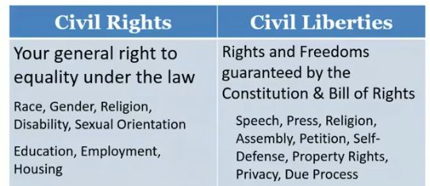
Civil liberties
p. 173
Suffrage
p. 187
Poll tax
p. 189
Double jeopardy
p. 179
Equal protection under the law | Part of the 14th Amendment that indicates that no state can “deprive a person” of equal rights under the law.
Right to legal counsel | Part of the 6th Amendment that guarantees the right to an attorney if you cannot afford one.
Trial by jury | Part of the 6th (Criminal) or 7th (Civil) Amendments that guarantees a person the right to have a jury trial if they choose to do so.
Enumerated rights | Amendments 1 – 8 are considered to be “enumerated” because they are written/numbered in the Constitution. | Enumerated rights  Unenumerated rights  Amendmts  1 – 8  Amendmt  9
Unenumerated rights | Amendment 9 is considered to discuss all of the rights that citizens have that are not listed/numbered in the Constitution (travel, jobs, college, etc.)
Civil Disobedience | Refusing to obey certain laws or commands of the government. Also known as non-violent resistance. This is a form of “respectful disagreement”. (Gandhi, Martin Luther King, Jr., etc.)
Segregation
p. 393

