Name: _________________________________________ Date: ________________

AMENDING THE CONSTITUTION
Important  Terms | amendment | a change to a constitution
 | propose | to officially suggest something
 | ratify | to confirm by expressing consent or approval
Amendment
PROPOSAL Methods

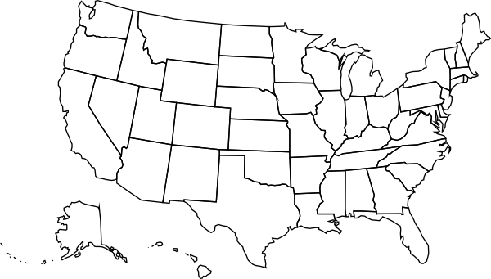
_______________________________

_______________________________

in ______ of the states.

_____________ of _____________

______________________________.

Amendment RATIFICATION Methods

2/3 of _______________________________

____________________________________

Congress then ________________________

____________________________________.

This method has been used _______ times.

_____________ of ___________

__________________________

__________________________.

This method has been used _______ times.

OR
What is the difference between an amendment and a law?
________________________________________________________________________________________________________
________________________________________________________________________________________________________
________________________________________________________________________________________________________
OR

