Civics

Grade 7 Social Studies

Week 7: May 11 - May 15

Your Week at a Glance

Daily Schedule (Suggested)

Day 1:

County Government Reading

Day 2:

County Government Reading

Day 3

Current Event-Florida Schools

Day 4

Current Event- Florida Schools

Day 5:

Levels of Government Scenarios

Additional Support:
CPalms: www.floridastudents.org

Directions for accessing:

- Go to floridastudents.org
- Choose Social Studies
- Choose Civics
- Choose the activity you want to complete. -Differentiate between local, state, and federal governments' obligations and services. (Standard #: SS.7.C.3.14)
- On the right hand side, click the tab that reads “captions” to read along.
County Government Name:

What is a County?

You already know that the United States is divided into smaller units of government called states. But what are states divided into? Counties! A county is the next smallest unit of government below a state. Counties make it easier to provide services directly to people. The county seat is the town or city in each county that serves as the home for the county government.

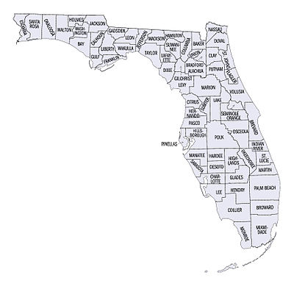
A county by any
other name...

- is still a county. But in

Alaska counties are called

boroughs, and in Louisiana

they are called parishes.

Counties Provide Services to You

You’ve probably benefited from county services without even realizing it.

Have you ever driven on a road? Needed a copy of your birth certificate? Called 911? Although every county is different, maintaining roads, keeping vital records, and providing emergency services are the kinds of services that counties might provide. But that’s not all. Here is a list of more services that counties might provide for their residents: Run elections, Keep property records,

Operate courts and jails, Plan how land will be developed,

Run hospitals, Give relief to the poor, Offer mental health services, Maintain Parks, Run disease prevention programs , provide clean water

Counties in the state of Florida

Paying for County Services

It takes money to provide all these services. Counties have three main sources of money to pay for it all: the federal government, the state, and the county itself. The smallest share of a county’s money comes from the federal government. A bigger share—usually almost one-third of a county’s money—comes from the state.
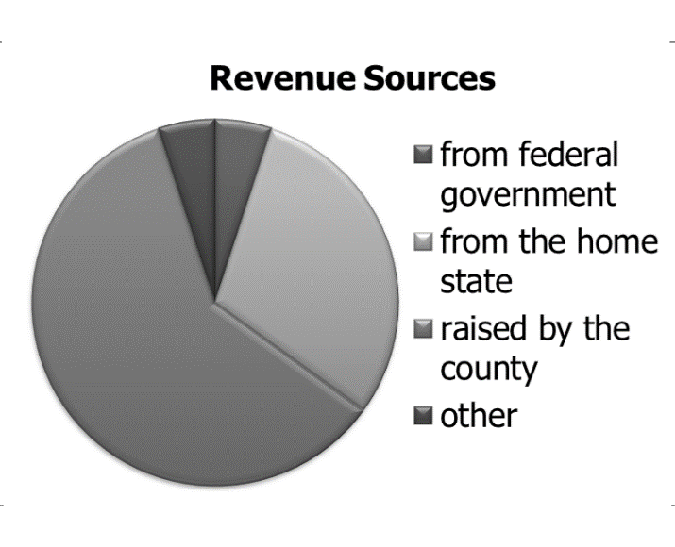

But the biggest source of money for a county is the county itself. Most of this money comes from property taxes people or businesses pay on land and buildings they own inside the county. Some counties also have a sales tax on items sold inside the county. Finally, counties raise money by charging fees for services the county provides. For example, a county may provide garbage collection, but people who participate have to pay for that service.

Sometimes the federal or state government make counties provide certain services but don’t give counties any money to pay for those services. These demands are called unfunded mandates because they are mandated (ordered) but not funded (paid for). For example, counties are responsible for running elections, but they do not receive any money to pay for the elections. Counties must provide these services even if it means raising more money on their own.

County Power
Counties don’t have magic powers. Instead, they get their power
from one of two places. In some states, the state itself gives counties
the power to carry out duties and provide services. Those states
follow Dillon’s Rule, which says that a county must get authority
from the state legislature before it can provide services. These states |  | Dillon’s Rule
see the county government as just another part of the state.
 | In other states, counties are considered to have natural powers of
 | their own. Maybe this is a little like magic, but it’s actually called
 | Home Rule. Under Home Rule, counties have the power to make
 | decisions for themselves about what services to provide. In these
 | states, counties have some independence from the state. But don’t
Home Rule | get the wrong idea—even in these states, state laws always trump
 | county laws.
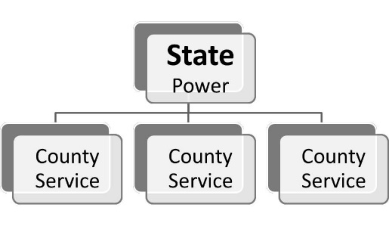
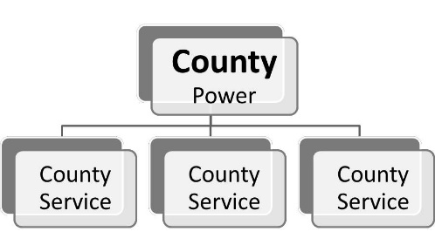

Who’s In Charge Around Here?

There are three ways a county’s government might be organized:

Commission Only County citizens elect several people to sit on a commission (also called a board). These county commissioners have some “legislative” power because it passes county laws (which are called ordinances) and figures out the county’s budget. It has some “executive” power because it decides what the county’s policies will be and carries out
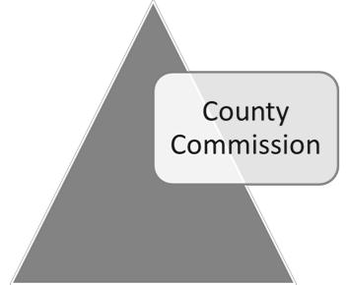
the laws it passes. Commissions also share some of their power with elected officials who oversee specific departments, such as the sheriff, clerk, or county judge.
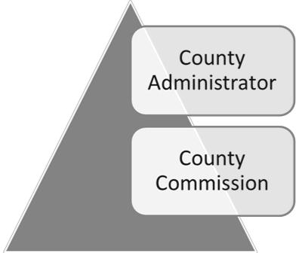

Commission/Administrator/Manager Under this system, the commission gives some of its “executive” power to an administrator. The commission chooses the administrator and has the power to fire that person. The administrator carries out the board’s decisions.
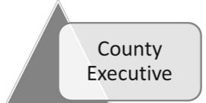

Commission + Executive Under this system, an elected person separate from the commission has the county’s “executive” power. This executive can sometimes veto decisions the board makes. This is more like a real legislative and executive branch,
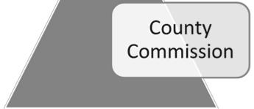
because the commission and the executive can check each other’s power.

Counties Go Way Back
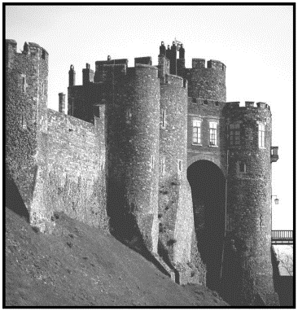

Well before the Unites States was formed, England was divided into units called “shires.” English shires served the local community and represented the national government. The thirteen English colonies in America borrowed the shire system and adapted it to their needs. When the United States government was formed, the writers of the Constitution did not say how local government should be run. As a result, county governments continued and developed into the county system we have today. Vermont’s county seats are still called shire towns!
A. True or False? Write true or false | each statement. If the statement is false, cross
out the part that is wrong and correct it on the line below. You do not have do anything with thumbs.

1. | Counties in the United States come from an ancient American Indian tradition. |  | or
 | _______________________________________________________________
2. | Rules for counties and local governments are spelled out in the U.S. Constitution. |  | or
 | _______________________________________________________________
3. | Counties have adapted to meet the needs of the communities they serve. |  | or
 | _______________________________________________________________
4. Counties all across the United States are managed the same way. |  |  | or
 | _______________________________________________________________
5. | Most of counties’ money comes from the federal government. |  | or
 | _______________________________________________________________
6. | The first counties were units of government created as “districts.” |  | or
 | _______________________________________________________________
7. | The main in-county source of income for most counties is the sales tax. |  | or
 | _______________________________________________________________
8. | A county executive can be fired by the county commission. |  | or
 | _______________________________________________________________
9. | Unfunded mandates are services the federal government demands and pays for. |  | or
 | _______________________________________________________________
10. A county commission can act as both a legislative and executive branch. |  |  | or
 | _______________________________________________________________
B. County Power. Label and define Home Rule and |  | Dillon’s Rule.
 | _________________ | _________________
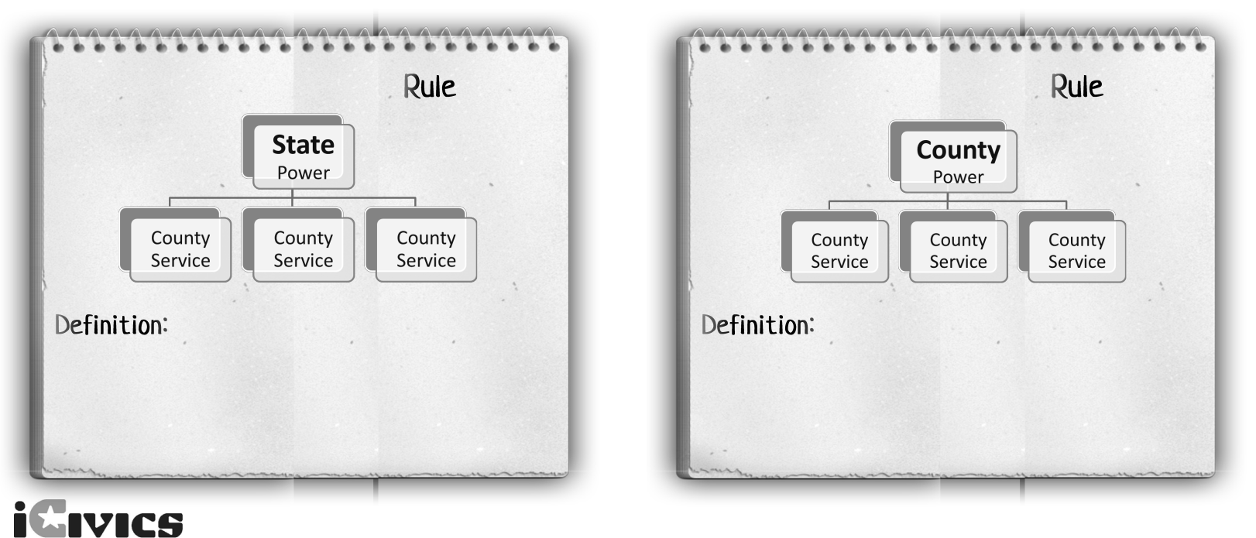

County Government Name:

C. County to the Rescue! Help each person below find the county service they need.
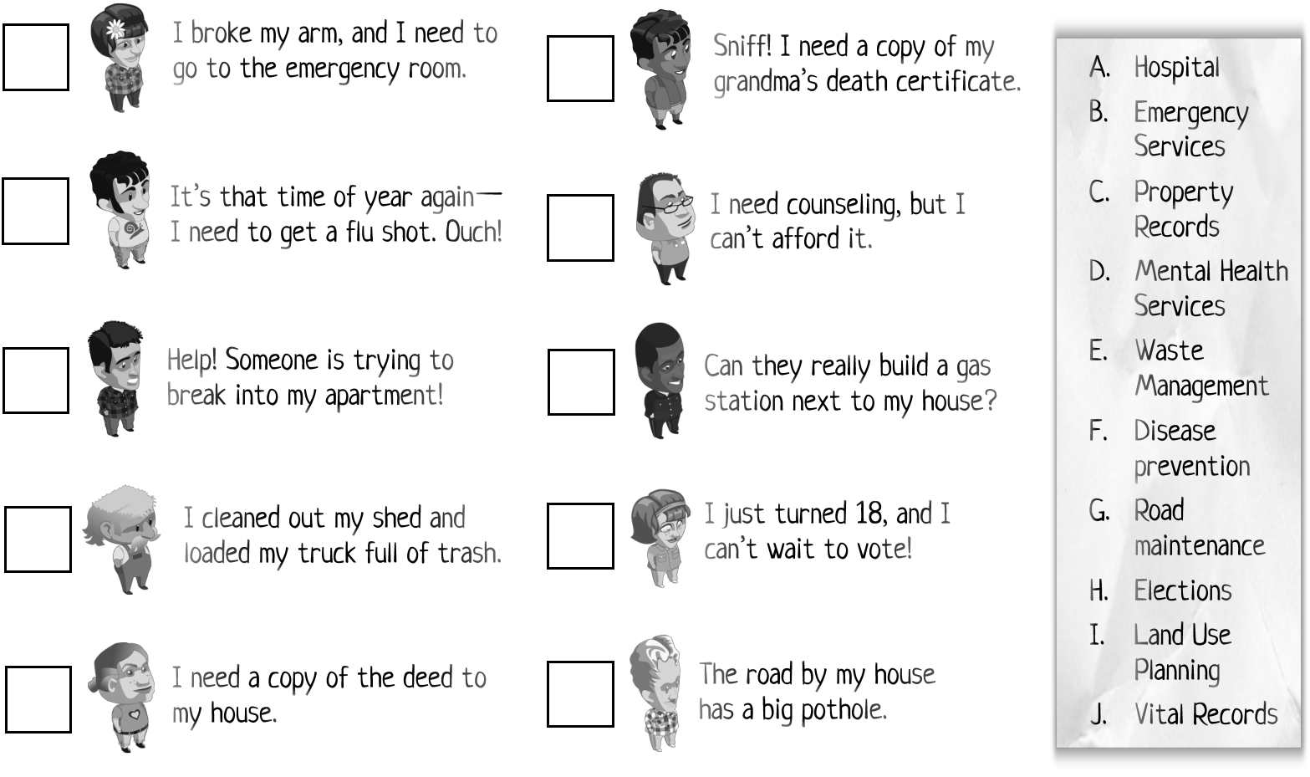

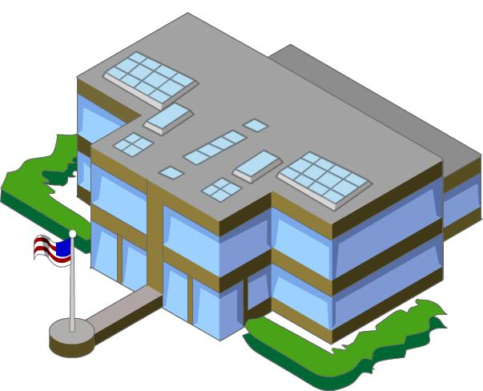

County Government Name:
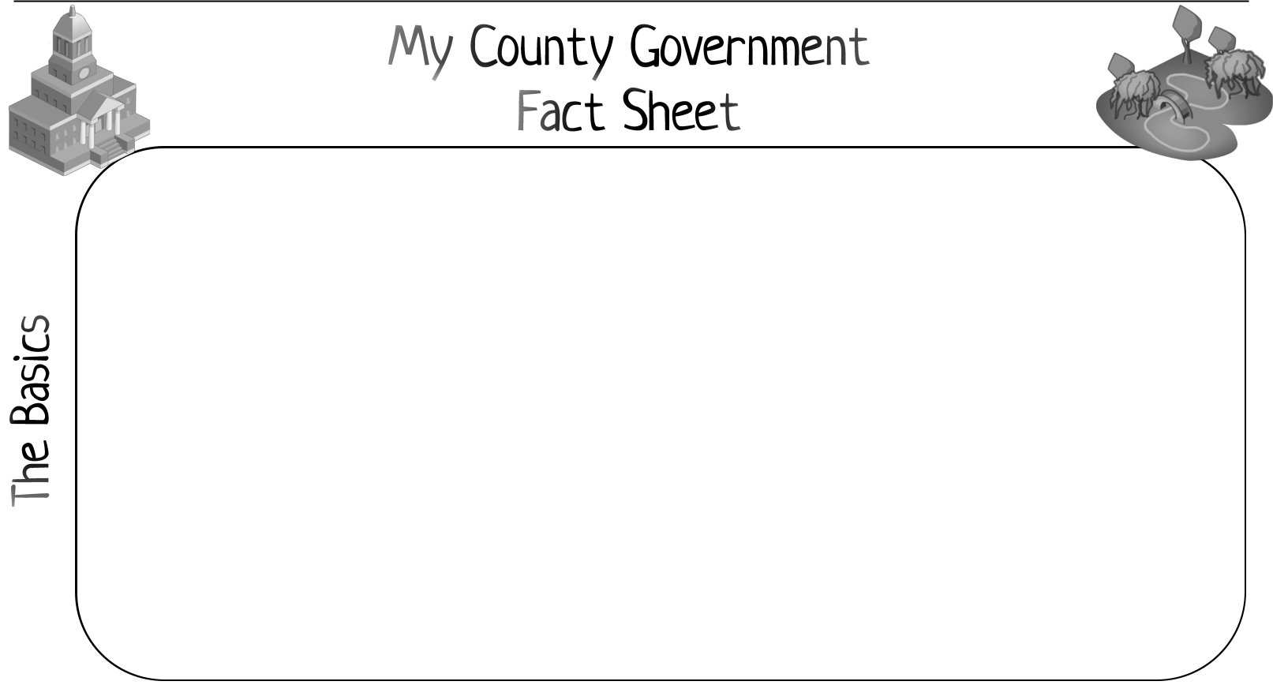

County Name: _______________________________ County Seat: ____________________

State:______________________________ | When was it established? ___________________
List the Leon County Commissioners.  http://cms.leoncountyfl.gov/Home/County-Commission/Meet-Your-Commissioners |  | Use the map to determine your district. http://cms.leoncountyfl.gov/Home/County-Commission/Meet-Your-Commissioners  Who is your county commissioner?
.

How many people live in your county?

__________________________

What is the largest city in your county?

__________________________

How large is your county (in square miles)? __________________________

My county has a ...

County Commission/Board

County Administrator

County Executive

Where are the county offices located?

_________________________________

_________________________________

?

__________________

The population in my county is...

growing or shrinking

My county is more...

rural or urban or mixed

My county has...

industry agriculture business

major university major tourist site

other: ________________________

Pick three agencies or departments and briefly describe the kind of work they do.

- The ______________________department focuses on _____________________________
_____________________________________.

- The ______________________department focuses on _____________________________

_____________________________________.

- The ______________________department focuses on _____________________________

Name__________________________________________

Current Event- Florida Schools

As Re-Open Florida group recommends schools reopen in fall, Leon ponders what that looks like
CD Davidson-Hiers, Tallahassee DemocratPublished 11:40 a.m. ET May 5, 2020 | Updated 11:58 a.m. ET May 5, 2020
As Florida embarks on "Phase 1" of Florida Governor Ron DeSantis' plan to reopen the state during the coronavirus pandemic, school districts look to the future.
In its recent report to the governor, the Re-Open Florida Task Force recommended school districts reopen campuses "full-time" in time for the next academic year.
The Florida Department of Education "should develop" a plan to "phase-in education" during the summer months and create "supplemental education" to support students who have fallen behind during the pandemic, the task force said.
Among those sitting on the task force's "industry working group" dedicated to education and other topics include:
- Richard Corcoran, Florida Commissioner of Education
- Jacob Oliva, Chancellor of the Division of Public Schools
- Michael Grego, Pinellas County Superintendent of Schools
- John Hage, CEO of Charter Schools USA
- Melissa Pappas, Orange County Schools teacher of exceptional student education
- Morris Young, Gadsden County Sheriff
The working group is one of three groups underneath the task force's executive committee advising the governor. Corcoran also sits on the executive committee.
"Plans should be developed to resume on-campus learning, full-time, for the 2020-2021 school year," the task force says in its "ongoing considerations."
The report does not mention schools in its phases for reopening. Florida shuttered physical school sites for the remainder of this academic year.
While the broad direction from the state to reopen in the fall is clear, the path forward is uncertain for public school districts like Leon County, Florida's capital county.
From opening at 50% capacity to students eating lunch meals at their desks, "all options are on the table," Superintendent Rocky Hanna said Monday.
He spoke to the Tallahassee Democrat recently about what the school district plans to do for the future of local education as the coronavirus pandemic continues.
“Until we hear definitively from the governor, from the commissioner, it’s hard for us to plan based on hearsay," he said.
The district has created its own "work group" devoted to planning for "Pandemic 2.0." Assistant Superintendent Gillian Gregory is one of the district officials leading the initiative. Gregory oversees academic services at the district and is one of five assistant superintendents.
The work group is comprised of district staff in various departments which include nutritional services, academic achievement, exceptional student education and transportation.
"There are many, many parts to a pandemic response," she said.
A few members of the group, including Gregory, have already met to prepare. District officials also plan to meet with Pasco County Schools staff to compare notes on pandemic responses.
North of Tampa, Pasco County's school district is similar to Leon in size, Gregory said, and is a district that has figured out the "one-to-one" — the ratio of students who have laptops or computers.
Leon County Schools is looking at a three-tiered approach for forging on during the pandemic. The first avenue has to do with continuing distance-learning and building upon what is already in place.
"What we're trying to do is improve what we did in the spring with more information from our community that, should something happen in the fall, we'll have a better experience for students than what we've all lived through in the past couple of weeks," Gregory said.
Hanna also told the Democrat that the school district is aware more students need laptops and that the district should limit the number of online platforms teachers are using. District officials are looking into ways to connect more students with the Internet and streamline platforms, he said.
On Thursday, the district launched its "SmartBus Initiative" and outfitted 15 buses with Wi-Fi routers to park at select sites during the week. School Board member Alva Striplin also has pushed the district to spend the funds necessary, or take out a loan, to cover the cost of getting kids online.
In the past, the district has reported that roughly 95% of students have engaged with their schooling, which translates to roughly 32,100 of the 33,800 traditional public school students in the county.
The second tier in the district's game plan has to do with students fully returning to "brick and mortar" school sites, Hanna said.
The logistical challenges will require the summer months to plan as the district weighs health guidance coming from the county health department and instructions from local governments and the state's education department.
The third and more sobering path for the district is "we come back and then are told again to retreat home," the superintendent said.
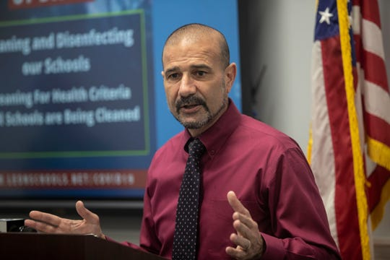
Leon County Schools Superintendent Rocky Hanna holds a press conference to provide updates on how the coronavirus is impacting the schools moving forward, Tuesday, March 17, 2020. (Photo: Alicia Devine/Tallahassee Democrat)

When asked by a reporter at a recent press conference announcing the "Plan for Florida's Recovery," Governor Ron DeSantis said any future spikes of confirmed cases of the coronavirus would be evaluated, but would not necessarily shut down the whole state.
In Leon County, Hanna is looking at how restaurants handle their reopenings as a vague indication for what might happen with schools. In the first phase of DeSantis' plan, restaurants may operate at 25% capacity with 6 feet between patrons.
But Hanna said he thinks schools should be "all in or not in" and that a "soft" open isn't practical. He added that what the district could not afford was a "week by week" uncertainty like what happened as students went home in March for spring break and then never returned.
“A public school system is just not that easy to control," he said. “I’d really prefer all in and let’s just be done with this."
Directions: After reading the article, answer the following questions.
  - Who is the governor of Florida?
  - What is the recommendation of the Re-Open Florida Task Force on opening schools in the Fall?

  - What does the task force recommend for students who have fallen behind?

  - Name two members of the Re-Open Florida Task Force task force and their titles.

  - Why might the task force include Morris Young, the Gadsden County Sheriff?

  - Who is the Superintendent of Schools for Leon County?

  - What are two options schools are looking at to promote social distancing when schools reopen?

  - What is the opinion of Superintendent Rocky Hanna on the re-opening of Leon County schools in the Fall?

  - In your opinion, should schools Leon County schools reopen in the Fall? Defend your response.

  - What suggestions for promoting social distancing and increased sanitation would you give Superintendent Hannah for reopening of Leon County schools in the Fall? Think about classes or activities where students are crowded together. What can be done to prevent too much close contact?
Name_____________________________

Scenarios for Levels of Government

Directions: Highlight, circle, or change the font color of the correct answer.

1. A community center in your neighborhood may close due to lack of funding. You have an idea for a fundraiser. Which level of government do you contact?
A. National- U.S. Senator B. State- Florida Representative C. Local- County Commissioner

2. You want a law passed that changes the legal driving in Florida to age to 15 . Which level of government do you contact?
A. National- U.S. Senator B. State- Florida Representative C. Local- County Commissioner

3. You are concerned about the idea of going to war with North Korea. Which level of government would you contact?
A. National- The President B. State- The Governor C. Local- The Mayor

4. You would like to have an additional extra-curricular class, such as computer programming or auto mechanics added to the middle school schedule in Leon County. Which level would you contact?
A. National- The President B. State- The Governor C. Local- The School Superintendent

5. You want to have a library built in your neighborhood. Which level of government do you contact?
A. National- U.S. Senator B. State- Florida Representative C. Local- County Commissioner

6. The roads in Tallahassee need to be repaired. Which level of government do you contact?
A. National- U.S. Senator B. State- Florida Representative C. Local- City Commissioner

7. You would like to see your face printed on the fifty dollar bill. Which level of government do you contact?
A. National- U.S. Senator B. State- Florida Representative C. Local- County Commissioner

8. You would like to see a new recycling laws passed for Florida. Which level of government would you contact?
A. National- U.S. Senator B. State- Florida Representative C. Local- County Commissioner

9. You want to get your fishing license so you can go on a fishing trip in Miami. Which level of government would you contact?
A. National B. State C. Local

10. You want to make sure the food you are buying from the grocery store has been inspected and is safe to eat. You look for the USDA stamp that verifies it has been inspected by the United States Department of Agriculture. Which level of government does the USDA represent?
A. National B. State C. Local

