Civics
Grade 7 Social Studies
Week 3: April 13- April 17

Your Week at a Glance

Daily Schedule (Suggested)
Day 1:
Definition Depot
Vocabulary Quiz using Definition Depot

Day 2:
International Conflicts Reading- Choose One
International Conflicts Video and Discussion Questions- Watch one video and complete the discussion questions on Microsoft Teams or on paper.

Day 3
International Conflicts Reading- Choose One
International Conflicts Video And Discussion Questions- Watch one of the videos and complete the discussion questions on Microsoft Teams or on paper.

Day 4
International Conflicts Reading- Choose One
International Conflicts Videos- Watch one of the videos and complete the discussion questions on Microsoft Teams or on paper.

Day 5:
Quizizz: Domestic and Foreign Policy and International Affairs Bellringers Assessment
Additional Support on the next page

Additional Support:

CPalms: www.floridastudents.org Directions for accessing:
-Go to- FloridaStudents.org
-Choose Social Studies
-Choose Civics
-Choose the activity you want to complete. See below.

- On the right hand side, click the tab that reads “Captions” to read along.

Activity 1- Compare different forms of government (direct democracy, representative democracy, socialism, communism, monarchy, oligarchy, autocracy). (Standard #: SS.7.C.3.1) Both Modules
Activity 2- Differentiate concepts related to United States domestic and foreign policy. (Standard #SS.7.C.4.1) There is only one module.

Brain Pop: You can create a FREE family access account.
Videos: Foreign Policy and International Relations Videos: • Communism • Democracy • Armed Forces • Cold War • Korean War

Name: Date: Per.:
Civics Definition Depot – “Foreign Policy”
nDirections: Complete the chart below with definitions and colorful images, Sentence, or Synonym that demonstrate you understand the
meaning of each word! (Definitions should come from online.)

Word/Pg. # | Definition | Image/Sentence/Synonym
Domestic policy
Foreign policy
Diplomat | a person appointed by a country to conduct diplomacy with one or more other countries or international organizations.
Diplomacy
Treaty
Ambassador
Embassy | the official residence or office of an ambassador

U.S. State Department
Secretary of State
Alliance |  | 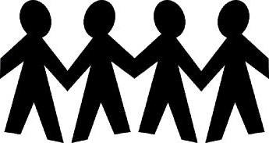
Allies | Nations united together for a common purpose such as assisting and protecting each other.
Foreign Aid
Foreign Affairs | Issues or concerns about other countries around the world.
International Relations | The study of relationships among different countries.
International Organizations | Groups of government or people from different countries working together to solve an issue that crosses country borders.

Name: Date: Per.:
“Foreign Policy”
Vocabulary Assessment
Matching: Match the definition of the concept to the term. Write the letter of your answer choice on the line provided.
1. Ambassador A. Nations united together for a common purpose such as assisting and protecting each other.

2. Domestic Policy B. The plan that a country follows for interacting with other countries

3. Foreign Policy C. An organization that promotes peaceful coexistence and worldwide cooperation

4. Allies D. A written agreement between two nations

5. United Nations

6. Treaty

7. World Court

8. Embassy

- Deals with issues directly related to a nation

- Representatives of their countries that are appointed by the president.

- Official residence of an ambassador in a foreign country

- Handles international legal disputes

Picture It!: Examine the images below. Using your knowledge of Civics and of the concepts of domestic policy and foreign policy, circle the term that is best represented by the image.

9.  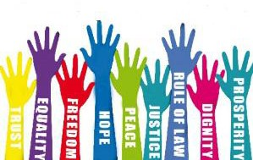  Human Rights | Domestic Policy Foreign Policy | 10.  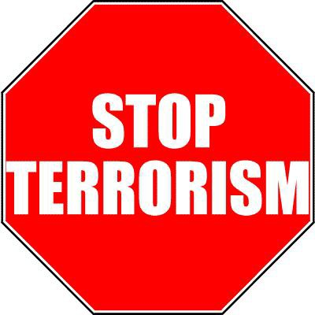  Terrorism | Domestic Policy Foreign Policy
11.  American education | Domestic Policy Foreign Policy | 12.  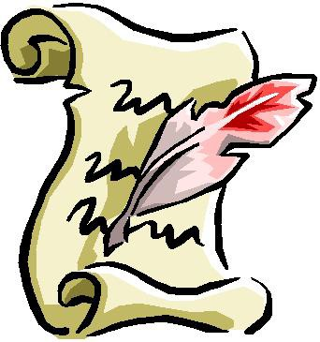  Approving a new treaty | Domestic Policy Foreign Policy

Fill in the Blank: Write the term that best completes the sentence.

  - The United States has established with many countries of the world to help each other with defense, economic aid, and scientific information (alliances/wars).
  - The Department is the principal organization for carrying out U.S. foreign policy as established by the president (U.S. Treasury/ U.S. State).
  - The organization that promotes peaceful coexistence and worldwide cooperation, and was created after World War II, is known as the (United Nations/World Trade Organization).
  - A major responsibility of the is to ensure that rules of international trade are correctly applied and enforced (United Nations/World Trade Organization).
  - The is an alliance of 28 countries from North America and Europe that plays an important role in crisis management and peacekeeping (World Trade Organization/North Atlantic Treaty Organization).
  - The international organization that provides assistance to children and mothers in developing countries is called (United Nations Children’s Fund/International Red Cross).
  - Any government program that provides economic or military assistance to another country is called

(foreign aid/domestic aid).

  - The agreement that follows free trade among the United States, Canada, and Mexico is known as the

(North American Free Trade Agreement/United Nations World Bank).

SCENARIO: WORLD WAR I (1914-1918)
A local European war soon became a global war that lasted from 1914-1918. World War I was the first war that involved nations (28) from around the world, and is commonly called The Great War or The War to End All Wars.

World War I - Outbreak of War
On June 28, 1914, a Serbian named Gavrilo Princip assassinated Franz Ferdinand, the Archduke of Austria, in Sarajevo. Exactly one month later, Austria-Hungary declared war on Serbia. The war divided Europe into two armed camps - on one side was the Triple Alliance made up of Germany, Austria-Hungary and Italy, and their enemy was the Triple Entente of France, Russia and Great Britain. As other countries began to join sides, the Triple Alliance became known as the Central Powers and the Triple Entente became the Allied Forces.

The Role of the United States
Most Americans favored staying out of the conflict and President Wilson publicly and formally stated that the U.S. would follow a policy of neutrality, not choosing a side. In three years, however, the U.S. would become involved in the war.

As the war in Europe raged on American sympathies were clearly on the side of the Allied Forces. When the war began, England implemented a block of German ships in the hopes of cutting off their supplies. Germany responded by using submarines, known as U Boats, to sneak up on their enemy and sink their ships. Germans did not limit their attacks to military ships. Any ship sailing in the war zone was considered an enemy. This became known as unrestricted submarine warfare. On May 7, 1915 the British cruise ship Lusitania was sunk off the coast of England. Over 1,198 passengers including 128 Americans were killed. Americas were furious and demanded a stop to this type of attack.

After this attack, President Woodrow Wilson began to actively campaign for Americans to support the Allied Forces. Besides being culturally similar, England and France were U.S. trade partners. From 1914 to 1916, trade with the Allies grew from $825 million to $3.2 billion. If the Allies were to lose the war, U.S. trade would be threatened. Americans increasingly saw Germany as the enemy. Germany was a dictatorship fighting against the more established democracies of the world. As a democratic nation, the U.S. felt obligated to support them and began fighting with the Allied Forces.

World War I - Fighting on the Front
WWI was different from previous wars because soldiers used efficient weapons like machine guns, artillery, tanks and air force. Military operations began in three major areas in Europe - the western front (France/Belgium), the eastern front (Russia) and the southern front (Serbia). Many of the deadliest battles occurred during WWI, including Ypres, Vimy Ridge, Somme and Gallipoli. Although thousands of soldiers died during these battles, they were all turning points for the Allied Forces in helping them win World War I. On October 3, 1918, Germany requested a cease-fire. The war ended on the 11th hour of the 11th day of the 11th month, when the warring parties signed the Armistice and agreed to stop fighting.

Adapted from http://www.kidzworld.com/article/5701-overview-of-world-war-i and http://www.socialstudieshelp.com/Lesson_75_Notes.htm

SCENARIO: WORLD WAR II (1939-1945)

For Americans, World War II had a clear-cut purpose. People knew why they were fighting: to defeat tyranny. Most of Europe had been conquered by Nazi Germany, which was under the control of dictator Adolf Hitler. The war in Europe began with Germany's invasion of Poland in 1939. Wherever the Nazis went, they conducted a campaign of terror, mainly against Jews, but also against other minorities. In Asia and the Pacific, Japanese armies invaded country after country, island after island. On December 7, 1941, Japanese planes bombed the U.S. Navy base at Pearl Harbor in Hawaii, a U.S. territory at the time. The next day, the U.S. Congress declared war, taking the U.S. into World War II.

What Caused World War II?
Most historians believe that the causes of World War II can be traced to World War I (1914- 1918). Americans had fought in that earlier war to "make the world safe for democracy." Those were the words and goals of U.S. President Woodrow Wilson. But the peace treaties that ended World War I did not make the world safe for democracy. Instead, they caused bitterness and anger that led to World War II. Germany and its allies had been the losers in World War I. Germany was stripped of one sixth of its territory and forced to pay huge reparations (payments by a defeated country for the destruction it caused in a war). After World War I, Germany suffered from high unemployment and runaway inflation. German money became almost worthless. Many Germans were angry about the peace treaty that ended World War I. In the early 1930s, the world was hit by an economic depression. Workers lost their jobs, trade fell off, and times were hard. People looked for leaders who could bring about change.

Rise of Dictatorships
Germany, Italy, and Japan all came under the rule of dictators or military leaders. Mussolini, a dictator, took power in Italy in 1922. Military leaders took control of Japan in the early 1930s. In Germany, Adolf Hitler, leader of the Nazi Party, gained power in 1933. These leaders promised to restore their countries to greatness. But they set up totalitarian governments (A totalitarian government is controlled by a single political party that allows no opposition and tightly controls people's lives.). Hitler began to arm Germany for war. Japan invaded China. Mussolini sent Italian troops to conquer Ethiopia, in Africa.

A World at War
Hitler had a plan to conquer Europe. He began by taking Austria, then Czechoslovakia. As Winston Churchill, who became Britain's wartime leader, said, "Britain and France had to choose between war and dishonor. They chose dishonor. They will have war." Churchill's words came true. In 1939, German troops invaded Poland. World War II in Europe had begun. The U.S. did not enter the war until December 1941, but once it did, it took a leadership role. U.S. troops fought in North Africa, Europe, and the Pacific. At home, Americans rolled up their sleeves to out produce the Axis powers (Germany, Italy, and Japan) in the weapons of warplanes, battleships, and guns.

A Changed World
Germany surrendered on May 7, 1945, ending the war in Europe. The war in the Pacific did not end until after the U.S. dropped two atomic bombs on Japan — the only time such bombs were ever used in war. Japan surrendered on August 14, 1945.

SCENARIO: THE KOREAN WAR (1950-1953)
The Korean War was fought between South Korea and communist North Korea. The war ended with little resolution and the countries are still divided today.

Before the War
Before the war, the northern half of Korea was under the control of the Soviet Union and the southern half was under the control of the U.S. The two sides were divided at the 38th parallel. Eventually two separate states formed with North Korea forming a communist government and South Korea forming a capitalist government. The two sides did not get along and there were constant clashes and battles along the border at the 38th parallel.

North Korea Attacks

On June 25, 1950 North Korea invaded South Korea. The South Korean Army fled and forces from the United Nations came to help out. Supporting North Korea were the Soviet Union and the People's Republic of China. Supporting South Korea were the United States, Great Britain, and the United Nations. The U.S. Army and United Nations forces were led by General Douglas MacArthur.

Soon the South Korean government only occupied a small part of Korea on the southern tip.

At first the United Nations and the U.S. were only trying to defend South Korea. However, after the first summer of fighting, President Truman decided to not only defend South Korea but also to try and rid North Korea of communism. General MacArthur led the UN forces on an attack and they were able to defeat much of the North Korean army. He took control of South Korea up to the 38th parallel. MacArthur continued to be aggressive and pushed the North Koreans all the way to the northern border. In response, the Chinese sent their army to enter the war. With the two sides of Korea divided at the 38th parallel, the two sides would battle at this line for the rest of the war.

End of the War

When Dwight D. Eisenhower became president of the U.S., he was willing to compromise to end the war. On July 17, 1953, a treaty ended the war. Few things had changed. Both countries would remain independent, and the border would remain at the 38th parallel. However, between the two countries a 2-mile zone was placed as a buffer in hopes to prevent future wars.

Adapted from: http://www.ducksters.com/history/cold_war/korean_war.php

SCENARIO: BAY OF PIGS INVASION (1961)
In 1961 the U.S. sent trained Cuban exiles to Cuba to try and overthrow Fidel Castro’s government because they were trying to prevent the spread of communism to the Americas. The effort failed.

Before the Invasion

Fidel Castro helped to lead the Cuban Revolution in overthrowing the existing government of Cuba in 1959. He was a strong communist and was allied with the Soviet Union. This deeply concerned the U.S. due to the fact that this gave communism and the Soviet Union a place in the Americas. The CIA, or Central Intelligence Agency, was tasked with overthrowing Fidel Castro's government in Cuba. There were many people from Cuba who fled the country when Fidel Castro became leader. The people who fled were considered exiles. The CIA began to train these exiles. The idea was that they would sneak back into Cuba and begin a war against Castro. They would gather others and eventually overthrow Castro. The plan changed, however. The new plan was to help the exiles to invade the island, get the locals to join forces, and quickly take over.

Planning the Invasion

The invasion was originally planned to occur at the city of Trinidad, but President Kennedy thought that they needed a more isolated place. The Bay of Pigs was chosen instead. The idea was that planes would fly in first and destroy the Cuban air force. Then 1500 soldiers would land and they would try to convince people to join them in rebelling against Castro. The CIA tried to plan the invasion in secret, however, too many people knew and word got out. The Cubans knew the invasion was coming.

The Invasion

The invasion occurred on April 17, 1961. It did not go well. Although the Cuban air force was damaged by early air strikes, there were still Cuban planes left to attack the invaders. Once the invasion started, it took too long for the troops and ammunition to get off the ships. Before the ammunition could be unloaded, Cuban planes sunk the invader's ships. Some of the troops who were supposed to slow down Castro's forces on the ground landed at the wrong place or in the swamps. Soon the invaders were surrounded by a much larger force and were running out of bullets. They tried to retreat, but most were eventually captured and imprisoned.

Results

The result for the U.S. was that the U.S. government, especially the CIA, looked weak. It also seemed to strengthen Castro's government within Cuba and caused him to look to the Soviet Union as a military ally.

Adapted from: http://www.ducksters.com/history/cold_war/bay_of_pigs.php

SCENARIO: THE CUBAN MISSILE CRISIS (1962)

The Cuban Missile Crisis occurred in 1962 when the Soviet Union began to place nuclear missiles in Cuba. The U.S. government refused to allow this and, after 13 tense days and many secret negotiations, the Soviet Union agreed to remove the missiles.

Leading up to the Crisis

The U.S. put several nuclear missile sites in Turkey and Italy that were within range to strike Moscow, the capital of the Soviet Union. As a result, the Soviet Union government believed they needed missile sites that could strike at the U.S. At the same time the Cuban government wanted protection from the United States. They decided to work together and have the Soviet Union put nuclear missiles in Cuba that could strike the U.S.

How the Crisis Began

On October 14, 1962 an American spy plane flying over Cuba captured pictures of long-range Soviet missiles in Cuba. The missiles could reach any place in the U.S. and cause mass destruction. President Kennedy called a meeting with his main security advisors. President Kennedy and his advisers considered a number of options from diplomacy to a full attack and invasion of Cuba. The Joint Chiefs of Staff recommended an invasion to the president. They believed it was the only practical option. However, Kennedy was concerned that this would start World War III between the U.S. and the Soviet Union. Instead, he decided to set up a naval blockade.

Blockade

Kennedy announced his plan on October 22, 1962. He showed the world the missile bases in Cuba and said that the U.S. would block Cuba from receiving any additional weapons. He also said that any attack on the U.S. from Cuba would be considered an act of war from the Soviet Union. Over the next several days the crisis became more intense. The Soviet Union said they would not back down. By October 24th, Kennedy believed the U.S. would have to invade Cuba.

Negotiations

Although the Soviet Union publicly said they would not back down, they secretly negotiated with the U.S. Eventually the two sides reached an agreement. The Soviet Union would remove the missiles from Cuba as long as the United States agreed to never invade Cuba again. In secret, the U.S. also had to agree to remove their nuclear missiles from Turkey and Italy. The crisis was over, and it was seen as President Kennedy's greatest moment of world leadership.

Adapted from: http://www.ducksters.com/history/cold_war/cuban_missile_crisis.php

SCENARIO: THE IRAN HOSTAGE CRISIS (1979-1981)

The Iran hostage crisis occurred after the capture of the American embassy in Tehran, Iran by Iranian students on Nov. 4, 1979.

What Happened?

For several decades the United States had been the primary supporter of Muhammad Reza Shah Pahlevi, referred to as the Shah. The Shah was the primary leader of the autocracy in Iran. Eight
U.S. presidents provided the Shah with military and economic aid in exchange for oil. Some people in Iran were opposed to the Shah because he did not grant the people freedoms he promised in the 1960s. These people were also opposed to Americans because the U.S. was supporting the Shah. On January 16, 1979 the Shah and his family were forced to flee Iran due to extreme protests against his leadership. Following the Shah's departure, conservative Muslims led by the Ayatollah Ruhollah Khomeini staged a revolt, abolishing the Shah’s government and establishing an Islamic Republic.

On November 1, 1979 Khomeini urged his people to demonstrate against the U.S. On November 4 thousands gathered around the U.S. embassy in protest and the embassy was taken by force by members of the crowd. Out of 90 occupants in the U.S. Embassy in Tehran, 66 were originally taken captive. The hostages were often shown blindfolded to local crowds and television cameras.

What Was The U.S. Response?

President Carter decided to use economic pressure in this situation by stopping oil imports from Iran and freezing Iranian bank accounts in the United States. At the same time, he began several diplomatic initiatives to free the hostages, all of which failed. On Apr. 24, 1980, the U.S. attempted a rescue mission that also failed.

Resolution

In the United States, the failure to resolve the crisis contributed to Ronald Reagan's defeat of Jimmy Carter in the 1980 presidential election. After the election, successful negotiations began. On January 20, 1981, the day of President Reagan's inauguration, the United States unfroze around $1 billion in Iranian assets, and the hostages were freed after 444 days.

Adapted from: http://www.infoplease.com/encyclopedia/history/iran-hostage-crisis.html, http://encyclopedia.kids.net.au/page/mo/Mohammad_Reza_Pahlavi_of_Iran and http://academickids.com/encyclopedia/index.php/Iran_Hostage_Crisis

SCENARIO: GULF WAR I (1991)

The First Gulf War, also known as the Persian Gulf War, took place during January and February 1991. This conflict was between Iraq and a coalition of 32 nations including the United States, Britain, Egypt, France, and Saudi Arabia.

How Did It Start?

Iraq’s president Saddam Hussein invaded the country of Kuwait and declared that the invasion was a response to overproduction of oil in Kuwait. This overproduction cost Iraq an estimated
$14 billion a year because oil prices fell. Hussein also accused Kuwait of illegally pumping oil from an Iraqi oil field. Both of these reasons resulted in Iraq's invasion of Kuwait on Aug. 2, 1990.

What Did Other Countries Do?

The United Nations Security Council called for Iraq to withdraw from Kuwait and the U.S. stopped most trade with Iraq. On August 7, U.S. troops moved into Saudi Arabia to protect Saudi oil fields because Saudi Arabia borders Iraq and Kuwait. On November 29, 1990 the United Nations set January 15, 1991, as the deadline for a peaceful withdrawal of Iraqi troops from Kuwait. When Saddam Hussein refused, Operation Desert Storm was launched on Jan. 18, 1991.

The U.S.-led coalition of nations began a massive air war to destroy Iraq's military and their public works system. The coalition forces invaded Kuwait and southern Iraq on Feb. 24 and,
over the next four days, defeated the Iraqis and freed Kuwait. When U.S. President George H. W.
Bush declared a cease-fire on Feb. 28, most of the Iraqi forces in Kuwait had either surrendered or fled.

What Was The Result?

Although the war was a military victory for the coalition, Kuwait and Iraq suffered enormous property damage, and Saddam Hussein was not removed from power. Iraq agreed to peace terms but every effort was made by the Iraqis to disobey the terms, particularly the required weapons inspections by the United Nations.

Adapted from: http://education.yahoo.com/reference/encyclopedia/entry/PersGWar, Accessed April 2013

SCENARIO: GULF WAR II (IRAQ WAR) (2002-2009)
After the first Gulf War, the United Nations Security Council adopted Resolution 687. This resolution stated that all Iraq long-range missiles, nuclear, biological and chemical weapons must be destroyed.
On September 11, 2001 the United States was subjected to multiple terror attacks on the World Trade Center in New York City and the Pentagon, just outside Washington, DC. After these attacks, President George W. Bush accused Iraq of developing weapons that violated UN Security Council Resolution 687; the president wanted to make sure that UN weapons inspectors were allowed full access to Iraq. Through late 2002 and into 2003, Iraq reluctantly allowed weapons inspectors back in the country and seemed to be making progress, but President Bush was not satisfied.

The Iraq War Starts
On March 20th, 2003, the Iraq War began when the United States led a coalition of about 40 countries into battle with Iraq. Most of the forces were U.S. and British forces. The coalition invasion combined land, air and water assaults and moved through Iraq until the coalition forces controlled most of the large cities. On April 15th, 2003, the invasion was declared complete.
Over the rest of 2003 the coalition forces began to hunt down and capture all government figures from former Iraqi President Saddam Hussein’s leadership. This included the capture of Saddam Hussein in December 2003.

The War Changes
There were small-scale attacks on the U.S.-led forces after the invasion. Over time, these attacks became constant and increasingly deadly. Through 2004, both U.S.-led forces and Iraqi civilians were being attacked. The first election of an Iraqi government under the new constitution took place in 2005. That year also saw the heaviest attacks on the coalition forces and civilians. The new Iraqi government also took office in 2006, and former President Saddam Hussein was executed for his crimes against Iraq in December.
In 2007 there was a massive increase in U.S. forces in Iraq, and the attacks on them decreased. This was also the year when the Iraqi government voted in favor of coalition forces leaving the nation. In 2008, Iraq was finally able to start defending itself as the new Iraqi army was formed and its troops started basic training.

Conclusion
Since 2009, President Obama has reduced the number of troops in Iraq as the Iraqi armed forces started controlling the security of their own nation. While the situation in Iraq is not completely stable, the U.S. has greatly decreased its role there and is no longer at war with Iraq.
Adapted from: http://www.thefinertimes.com/War-in-The-Middle-East/iraq-war-summary.html

World War I | World War II | Korean War | Bay of Pigs
Why did the U.S. become involved? | Why did the U.S. become involved? | Why did the U.S. become involved? | Why did the U.S. become involved?
With whom was the U.S. involved in conflict? | With whom was the U.S. involved in conflict? | With whom was the U.S. involved in conflict? | With whom was the U.S. involved in conflict?
What methods did the U.S. use to deal with the conflict (e.g., diplomacy, military action, humanitarian, or  peacekeeping)? | What methods did the U.S. use to deal with the conflict (e.g., diplomacy, military action, humanitarian, or  peacekeeping)? | What methods did the U.S. use to deal with the conflict (e.g., diplomacy, military action,  humanitarian, or peacekeeping)? | What methods did the U.S. use to deal with the conflict (e.g., diplomacy, military action, humanitarian, or  peacekeeping)?
What was the outcome of the conflict? | What was the outcome of the conflict? | What was the outcome of the conflict? | What was the outcome of the conflict?

Cuban Missile Crisis | Iran Hostage Crisis | Gulf War I | Gulf War II
Why did the U.S. become involved? | Why did the U.S. become involved? | Why did the U.S. become involved? | Why did the U.S. become involved?
With whom was the U.S. involved in conflict? | With whom was the U.S. involved in conflict? | With whom was the U.S. involved in conflict? | With whom was the U.S. involved in conflict?
What methods did the U.S. use to deal with the conflict (e.g., diplomacy,  military action, humanitarian, or peacekeeping)? | What methods did the U.S. use to deal with the conflict (e.g., diplomacy,  military action, humanitarian, or peacekeeping)? | What methods did the U.S. use to deal with the conflict (e.g.,  diplomacy, military action, humanitarian, or peacekeeping)? | What methods did the U.S. use to deal with the conflict (e.g., diplomacy,  military action, humanitarian, or peacekeeping)?
What was the outcome of the conflict? | What was the outcome of the conflict? | What was the outcome of the conflict? | What was the outcome of the conflict?

Name

International Conflicts Videos and Discussion Questions

Directions: Watch each of the videos and respond to the questions. You may respond on paper or in the discussion on Microsoft Teams

World War I

https://www.youtube.com/watch?v=DHn1Egt6Xdg

    - Why didn't America get immediately involved in World War I?

    - What two significant events pushed the United States to declare war on Germany?

    - How did joining World War I affect how the rest of the world viewed the United States?

World War II Part 1 https://www.youtube.com/watch?v=UBI6ZzaP2Uk

1. Whose rise to power in Germany can be tied to the end of World War I?

World War II Part 2
https://www.youtube.com/watch?v=_yQyCTTPGuQ

- Why did many Americans prefer to stay out of World War II?

- Which two countries were allied with Germany?

- What happened on December 7, 1941?

Cold War
https://www.youtube.com/watch?v=wVqziNV7dGY

- Immediately following World War II, which country was split in half by the United States and the Soviet Union?

- Which famous comic book superhero was used as propaganda against the Soviet Union?

- Which military invention did both the US and the Soviet Union have that prevented direct war?

- Why did the Soviet Union place missiles in Cuba?

- Which war resulted in a defeat for the United States?

Quizziz
Directions: When participating in this activity use your first name, last initial.
International Affairs Code is available from your teacher. Please check their website or contact them. Play for an “A”!

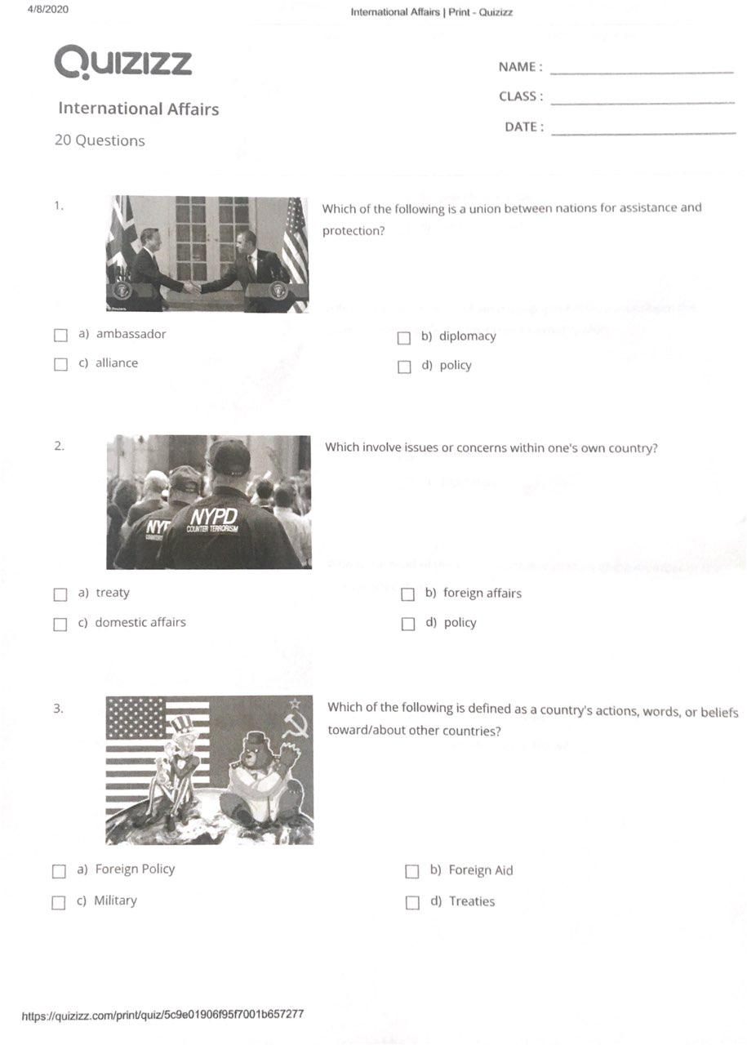

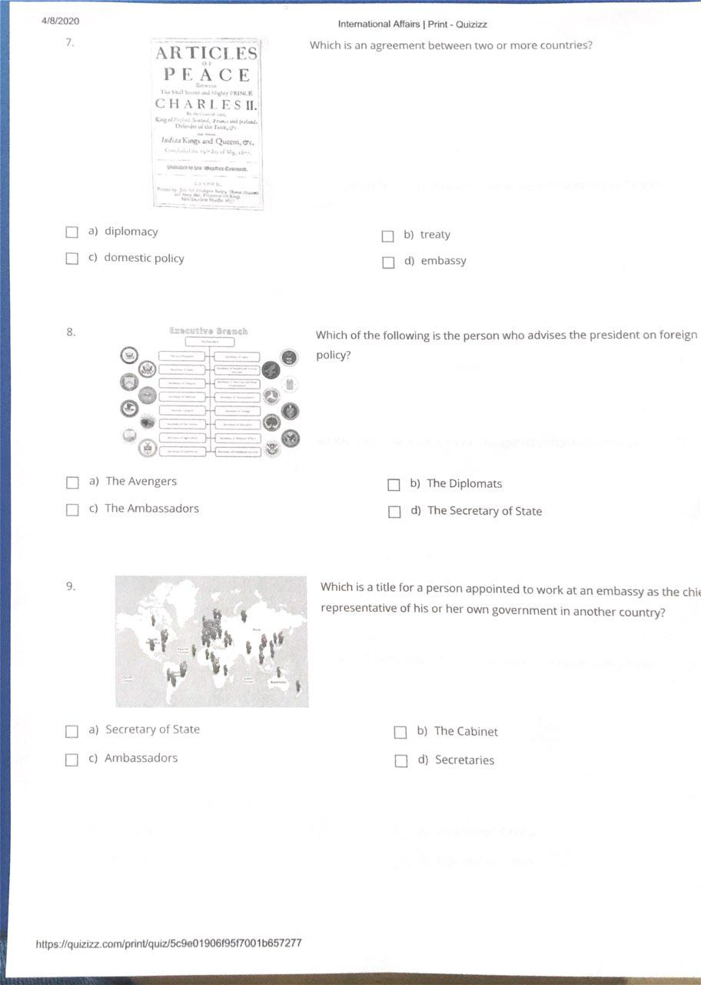
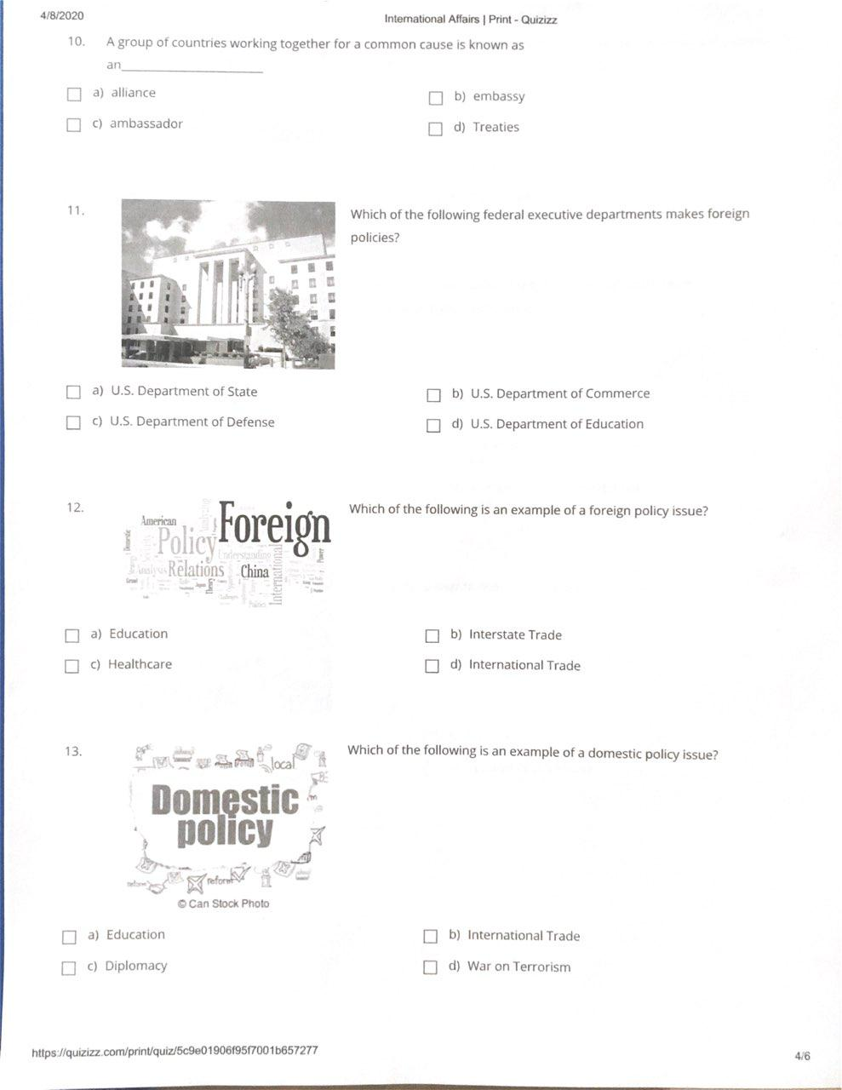
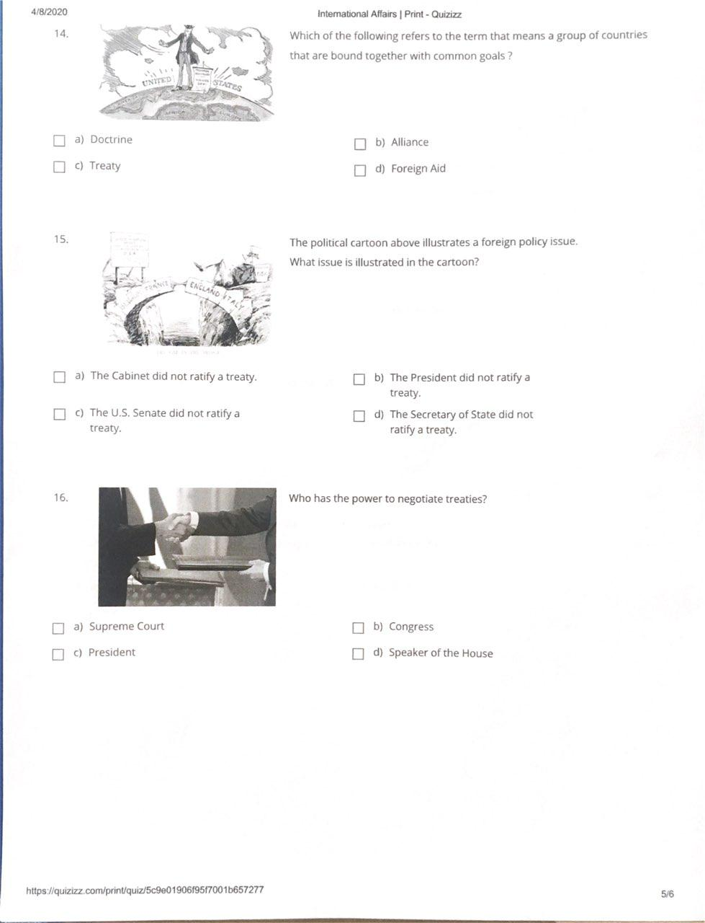
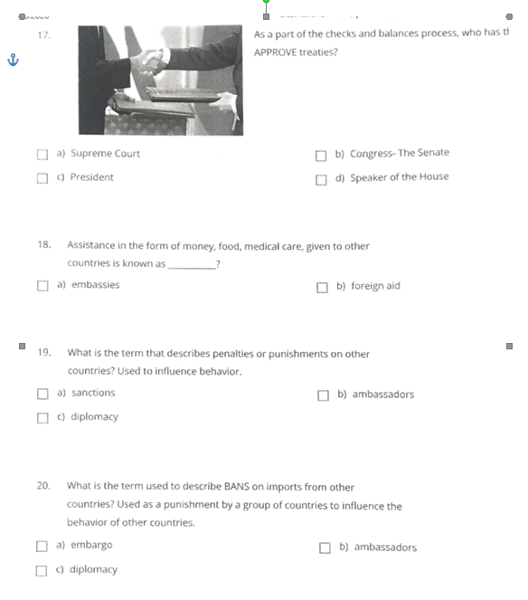
SS.7.C.3.2- Compare parliamentary, federal, confederal, and unitary systems of government.
Content Focus: governor, president, and prime minister.

1. In comparing the confederal and unitary forms of government,
__A. unitary is rule by many.
__B. unitary is rule by one.
__C. confederal is rule my one.
__D. confederal is rule by a small elite group.

2. A federal system of government
__A. gives all power to the national government.
__B. gives all power to the local government.
__C. shares power between national and local
governments.
__D. is the same as a unitary form of
government
.
SS.7.C.4.1- Differentiate concepts related to U.S. domestic and foreign policy.
Content Focus: Alliances, allies, ambassadors, diplomacy, diplomats, embassies, foreign affairs, international relations, Secretary of State and treaty

1. What is a responsibility of the U.S. Senate in foreign policy?
__A. nominating ambassadors
__B. introducing tax bills
__C. negotiating treaties
__D. ratifying treaties

2. Which action is an example of a foreign-policy decision?

__A. Congress increased providing support to newly arrived immigrants.
__B. The president requested a law to regulate pollution near international borders.
__C. Congress raised educational standards to make students competitive in a global market.
__D. The president signed an executive order restoring relations with a communist government.

SS.7.C.4.2- Recognize government and citizen participation in international organizations
Content Focus: Non-Governmental Organizations/International Non-Governmental Organizations (NGO/INGO), North American Free Trade Agreement (NAFTA), International Red Cross/Red Crescent, United Nations (UN), United Nations Children’s Fund (UNICEF), World Court, and World Trade Organization (WTO)

1. Which is an example of a way that a citizen
can seek participation in an international organization?

__A. email about internship opportunities at the
International Red Cross
__B. “like” the Facebook page of the World
Trade Organization
__C. request a trial before the World Court
__D. ask to join the United Nations

SS.7.C.4.3- Describe examples of how the United States has dealt with international conflicts
Content Focus: Bay of Pigs, Cuban Missile Crisis, Gulf Wars I and II, Iran Hostage Crisis, Korean War, terrorism, Vietnam War, World War I, and World War II

1. A country with very strong economic ties to the United States is allowing human rights violations to take place.
Based on U.S. Foreign policy, which is an appropriate first
response to show our country’s disapproval?

__A. Initiate a trade ban.
__B. Initiate public protests.
__C. Initiate diplomatic talks.
__D. Initiate a military operation.

2. During the Vietnam Conflict in the 1960s, the United States attempted to

__A. help the Soviet Union.
__B. increase trade with Vietnam.
__C. stop the spread of communism.
__D. stop Vietnam from invading South Korea.

