Name: ________________________________________________ Date: __________________ Per.: _______
Civics Definition Depot – Chapter 5: The US Constitution
Directions: Use the internet or your textbook to define the words below. Then, use a thesaurus, your brain, or help from a parent ot identify a synonym for each term OR write a sentence using the term that demonstrates your understanding of the word OR provide an illustration that shows that you understand the meaning of the term.
Word | Definition | Illustration
Preamble
p.130
Popular  Sovereignty /  (“We the People”)  p. 54 |  | 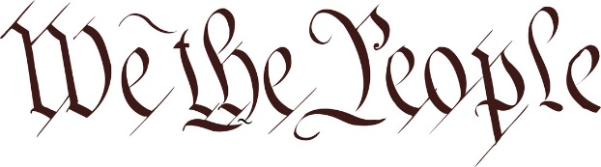
Limited government
p.86
Separation of Powers
p. 138
Checks and Balances
p. 139

Federalists  p. 127 |  | 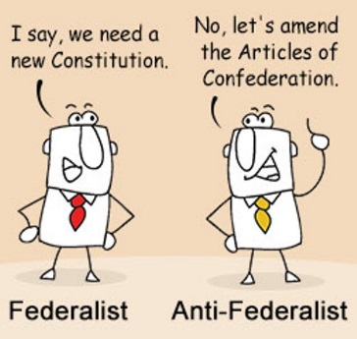
Antifederalists
p. 129
Ratification (ratify)
p. 118

Federalism
p. 127

Enumerated/  Expressed/  Delegated powers  p. 203 |  | 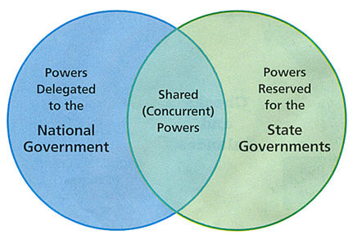
Reserved powers
p. 140

Concurrent powers
p. 140

Supremacy Clause | The clause, or section, of Article 6 of the US Constitution that states that the Constitution is the “supreme law of the land.”
Representative democracy/  republic  p. 85 |  | 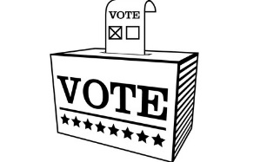
Federalist Papers | A collection of articles written in support of the Constitution as it was written at the time. | 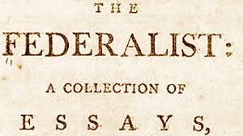
Antifederalist Papers | A collection of articles written in opposition to the ratification of the US Constitution. It led to the inclusion of the Bill of Rights (your civil liberties!). | 