Civics Bridge

Grade 7 Social Studies

Week 8: May 18- May 22

Your Week at a Glance

Daily Schedule (Suggested)

Day 1:

Budget Blaster

Day 2:

Shark Tank or Build a Zoo

Day 3

Shark Tank or Build a Zoo

Day 4

Shark Tank or Build a Zoo

Day 5:

Shark Tank or Build a Zoo

Additional Support:
CPalms: www.floridastudents.org

Directions for accessing:
- Go to floridastudents.org
- Choose Social Studies
- Choose Civics
- Choose the activity you want to complete. See below.
- On the right hand side, click the tab that reads “captions” to read along.
SS.7.E.1.3- Understand the fundamental concepts relevant to the development of a market economy.
SS.7.E.1.5 Assess how profits, incentives, and competition motivate individuals, households, and businesses in a free mar...
SS.7.E.1.6 Compare the national budget process to the personal budget process.

Week 8 will be a choice board.

Budget Blaster **  Must complete | Build a Zoo * | Shark Tank *
** Pick either “Build a Zoo” or “Shark Tank”

Budget Blaster
Instructions
- Off of the list of careers pick one
- Step One (on the paper)- Circle Single or Married
- Circle how many of kids, if you want any
- Pick one of the housing options
- Pick one of the car options
- Pick one of the career sections (this is based off the career you picked)
- Step two (on worksheet p.2)- Write your career and the salary that is listed on the paper
- Follow the steps for Step 3.
- Go to the Monthly Budget (Step 4) sheet- fill out according to what you picked. Use the back of the Career list sheet to help you fill it out. Make sure you total each box and then add up each box to get an overall total.
- Go back to Worksheet pg. 2 and do step 5. Fill in the blanks based off your above calculations and the Monthly budget sheet.

_Budget Blas t- Pick one Career from the list below
Accountant ($54,600)
Actor ($43,411)
Administrative Assistant ($27,400)
Advertising Manager ($78,654)
Aerospace Engineer ($72,590)
Air Traffic Controller ($107,780)
Aircraft Pilot ($148,810)
Architect ($73,650)
Artist or Related Career ($23,520)
Astronomer ($97,320)
Athlete ($56,120)
Athletic Trainer ($33,940)
Automotive Service Technician or Mechanic ($33,160)
Barber ($21,200)
Biological Scientist ($68,950)
Biomedical Engineer ($67,690)
Bus Driver ($26,017)
Cardiovascular Technologist/Technician ($38,690)
Carpenter ($49,990)
Carpet, Floor, and Tile Installer ($39,595)
Cashiers ($23,877)
Chef, Cook, or Food Prep Worker ($42,723)
Chemical Engineer ($76,770)
Childcare Worker ($22,982)
Chiropractor ($69,910)
Choreographer ($33,670)
Civil Engineer ($64,230)
Clergy ($63,130)
Coaches ($28,350)
Computer Scientists ($85,190)
Computer Software Engineer ($85,660)
Construction or Building Inspector ($41,620)
Construction Laborer ($37,753)
Construction manager ($69,870)
Cosmetologist ($21,800)
Curator ($36,470)
Customer Service Representative ($27,020)
Dancer ($20.33/hr)
Dental Hygienist ($64,910)
Dentist ($153,541)
Dietitians ($48,090)
Economist ($121,274)
Electrical or Electronic Engineers ($73,528)
Electrical or Electronics Installer/Repairer ($52,435)
Electrician ($62,791)
Emergency Medical Technician ($40,157)
Engineer ($82,582)
Farmer, Rancher, or Agricultural Manager ($61,481)
Fashion Designer ($73,819)
Financial Manager ($94,694)
Firefighting Occupation ($55,932)
Fisher or Fishing Vessel Operator ($41,471)
Fitness Worker ($30,727)
Flight Attendant ($37,357)
Food Service Manager ($41,780)
Graphic Designer ($45,007)
Home Appliance Repairer ($35,960)
Hotel, Motel, or Resort Desk Clerk ($21,470)
•
Human Resources Managers or Specialist ($79,032)
Industrial Production Manager ($83,952)
Insurance Sales Agent ($62,489)
Interior Designer ($58,151)
Interpreter ($39,255)
Judge ($109,842)
Landscape Architect ($61,927)
Lawyer ($102,698)
Legal Assistant ($44,881)
Librarian ($67,259)
Machinist ($19,742)
Massage Therapist ($38,762) Mathematician ($64,372)
Medical Laboratory Technician ($40,927)
Meeting or Convention Planner ($50,787)
Model ($34,980)
Musician ($49,849)
Nuclear engineer ($92,576)
Nurse ($65,120)
Nutritionist ($50,407)
Occupational Therapist ($70,565)
Optometrist ($91,964)
Painter ($44,647)
Paralegal ($60,998)
Paramedic ($33,382)
Pharmacist ($107,431)
Pharmacy Technician ($30,283)
Photographer ($30,363)
Physical Therapist ($70,113)
Physician Assistant ($90,580)
Physician ($188,174)
Physicist ($119,386)
Police or Detective ($42,910)
Probation Officer ($50,284)
Professor ($79,849)
Psychologist ($66,380)
Public Relations Specialist ($45,348)
Radiation Therapist ($73,266)
Radio Equipment Installer or Repairer ($58,388)
Radio Operator ($51,175)
Radiologic Technologist or Technician ($53,021)
Rail Transportation ($53,955)
Real Estate Broker or Sales Agent ($41,760)
Real Estate Managers ($55,017)
Receptionist ($30,072)
Reporter ($40,549)
Retail Salesperson ($31,049)
Secretary ($37,389)
Security Guard ($24,542)
Singer ($49,849)
Social Worker ($41,982)
Statistician ($46,033)
Surgeon ($263,893)
Surgical Technologist ($40,895)
Taxi Driver or Chauffeur ($20,369)
Teacher ($46,702)
Umpire ($21,260)
Veterinarian ($91,565)
Veterinary Technologist or Technician ($31,247)
Writers and Editors ($57,669)

Use this page to assist you when working on page 3.
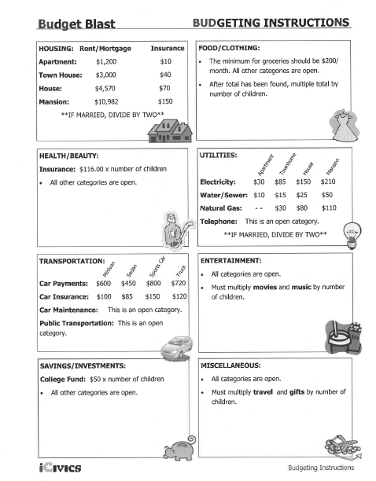
Step one: Circle one item in each line. In the career section there are two rows, just circle Medical, Legal, Education, Entertainment, Science and math, Service, or Business.

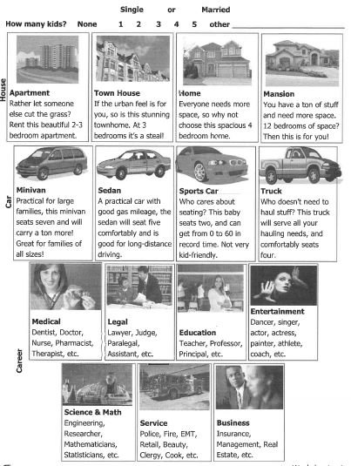
PAGE 1

Step Two: Find out how much you would make on average in your chosen career. Look back at the list provided.
Career: Salary:
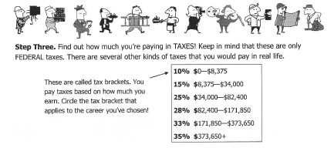
Salary X % of Taxes = (Total taxes paid)
Salary - Total taxes paid = (Spendable income)

X 12 =
Monthly Budget Total yearly spending

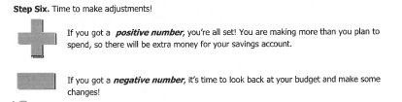PAGE 2

Monthly Budget
Step 4
Fill out this budget as best you can. You can/should ask your parent/guardian to help you. You may also use the internet. Remember this is for the entire month.
Housing  Rent/Mortgage: ___________________  Insurance: __________________  Home Repairs: ______________  Home Improvements: ____________  Home Goods: ______________  Add them all up  Total: ______________________________ | Food/Clothing  Groceries: ________________  Dining Out: _______________  Snacks: ___________________  Clothes: __________________  Shoes: ____________________ (be careful )  Add them all up  Total: _______________________________
Health/Beauty  Insurance: ______________________  Out of pocket expenses: __________________  Fitness: ____________________________  Grooming: ____________________________  Add them all up  Total: ________________________ | Utilities  Electricity: _______________________  Water/Sewer: _______________________  Natural Gas: ______________________  Telephone (Cell): ______________________  Add them all up  Total: ______________
Transportation  Car Payment: ______________  Car Insurance: ______________  Car Maintentance: _____________  Public Transportation (bus, taxi, Uber, lyft etc.) ________  Add them all up  Total: _______________________________ | Entertainment  Movies: __________________  Music: ________________  TV (cable, hulu, roku, etc): ________________________  Internet: ___________________  Computer (games, accessories, phone apps): _________  Add them all up  Total: ____________________________
Savings/Investment  Savings: ___________________  Retirement: __________________  Stocks/bonds: ________________  College Fund: _________________  Add them all up  Total: _______________ | Miscellaneous  Travel: __________________  Pets: ____________________  Gifts: ___________________  Donations: ______________  Other: _____________________  Add them all up  Total: _________________________

Add up all of the totals from each box.
Monthly Budget Total: ___________________________
PAGE 3
Now go back to page 2. Start under the Stop Sign with the stars around the sign. Put your monthly Budget Total on the line that says “Monthly Budget Total”.

Page 4

Build a Zoo
Materials needed: One large sheet of paper, scissors, tape or glue, and the images of animals or you can create a digital zoo.
Instructions for students: You are the manager of a new business that has decided to open a zoo. Your zoo is a private, profit-seeking business that will charge admission to visitors. The purpose of the zoo, as with any business, is to earn a profit.
Your task is as follows:
- You have to decide which animals to include in your zoo, but space is limited.
- You have 25 acres on which to build your zoo. You must use all 25 acres.
- Each type of animal requires a different amount of space, so you must choose which animals to put in your zoo. You need at least one male and one female of each animal so they can reproduce. (Except for the house of birds and reptile house)
- Choose which animals you will put in your zoo. They must be from the provided list of animals. If you do not see the animal of your dreams, I am sorry but they cannot be part of your zoo.
- Design a map layout of your Zoo.
- Be creative!!! On pg. 3 I have put links up to other Zoo’s maps so you can get an idea.
- If you want to add a train or a rollercoaster you can, that does not take up acres.
- You cannot use any of your zoo animals for meat that is served at the park
- If you want only one animal that is fine. It is your Zoo. You can call it a Sanctuary or a Rescue if you want.

-Below each animal is the number of acres just one of the animals requires. For example, one lion requires 2 acres of land. If you want four lions, therefore, you must use 8 of your 25 acres for lions.
Take a large piece of paper and using a marker, design the layout of your zoo. The design should look like a Zoo map. The paper represents the 25 acres you have for animals. Once you have decided which animals to include, how many of each animal, and calculated how many acres are to be used for each animal, cut out the animals you have chosen and glue each animal into its dedicated enclosure. On your map, make sure you have, how many acres a zoo animal gets, Zoo name, restrooms, ticket booths with prices, and food places with prices and any other means of making money (make sure you have the prices). You can have souvenirs stores as well. The map must have color. Make sure the Zoo map looks like a map and I can follow the different paths to each set of animals. If you choose to make a digital Zoo, you still must follow the same guidelines. The only difference is that you would not be using a large piece of paper, scissors, glue and cutting out the animals. Check the rubric on page 3 to make sure you have followed the directions. If you make the Zoo on a piece of paper you do not have to print the animals out in color but color them in once you print them.
Once you have completed construction of your zoo, answer the discussion questions that follow on a separate sheet of paper.

Discussion Questions:

- Did every animal make it into your zoo? Why or why not?

- Did you include a turkey or a cow in your zoo? Why or why not?

- Why didn’t you have a zoo with only monkeys?

- Which type of elephant did you choose? Why did you choose the type you did and not the other?

- What is the last animal to make the cut for your zoo?

- What is the animal that just missed the cut for your zoo?

Rubric:
______ Zoo Name
______ Acreages equal 25
______ Acreages displayed on map
______ Prices for Tickets, and any other way to make profit
______ Discussion Questions
______ Color
______ Neatness
______ Extra WOW
Comments:

Links to sample Zoo maps
https://www.si.edu/content/Accessibility/matm/nzp/zoo-map.pdf
https://www.phoenixzoo.org/visit/zoo-map/
https://www.rosamondgiffordzoo.org/zoo-map
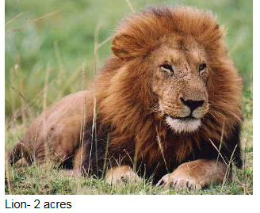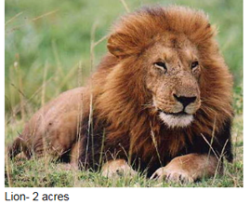
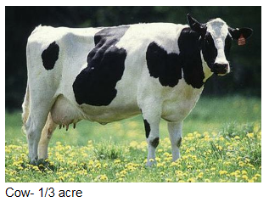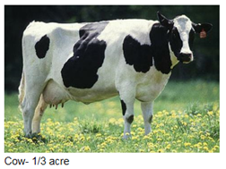
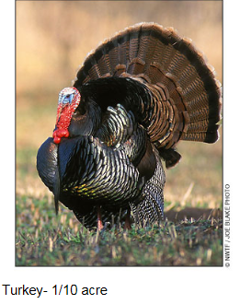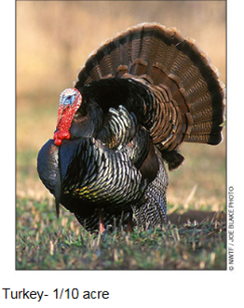
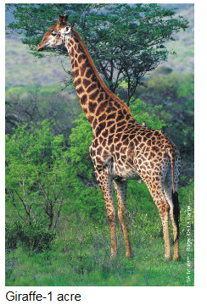

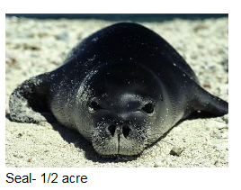
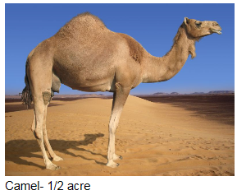
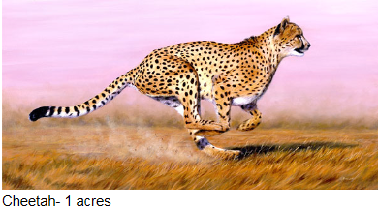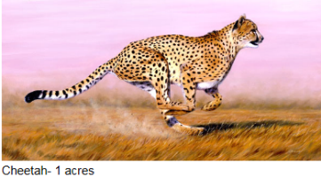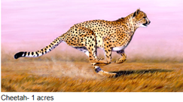
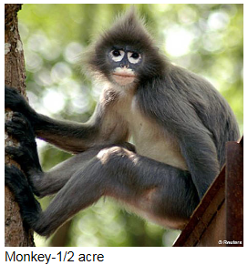
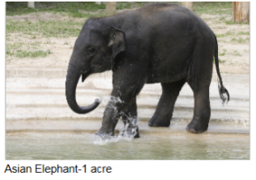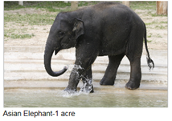
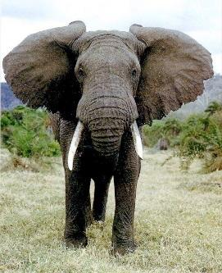 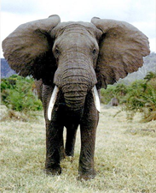 African Elephants – 3 Acres
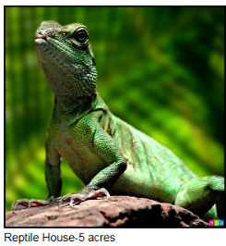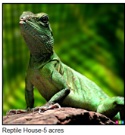
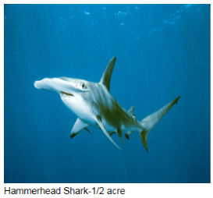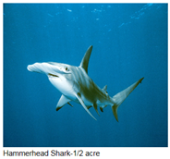

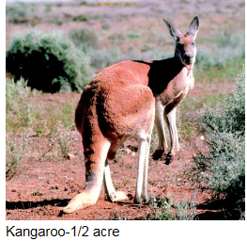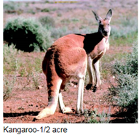

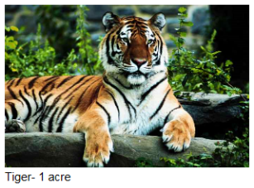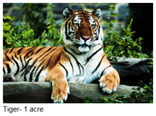

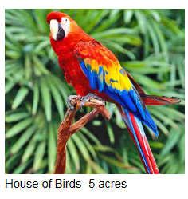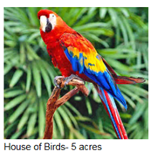

Shark Tank Project
Economics Lesson
Info: Shark Tank is a economics and business related TV show that airs on ABC. The basis of the show is that people come up with ideas or inventions and present them to the panel. The panel will decide if they want to put in their money or invest in the product.
***NO REAL SHARKS ARE HURT TAPING THE SHOW***
Directions: As you watch the first show, please fill in the blanks according to the episode. Scrub Daddy part 1: https://www.youtube.com/watch?v=itqrdO4kdKA
Part 2: https://www.youtube.com/watch?v=IPAw_C4DyFU&t=3s

- What is the idea or product?
- Did they get a deal?
- What was the deal worth?

Directions: Now that you have the basics, lets watch another episode and see what you can fill out.
2nd Video: https://www.youtube.com/watch?v=SL-mdEbx4jc&t=94s
2nd Video Follow Up: https://www.youtube.com/watch?v=MEtNdEO-Jfg
- What is the business concept that was presented?

- What did the presenter do well? Dress? Humor? Data?

- What could the entrepreneur have done to improve his/her presentation?

- What were the strengths and weaknesses of the business proposal?

Strengths | Weakness
- What deals are being offered by the investors?

- Any counter-offers? If so, what are they?

- What are the responses of the “sharks”? Do you agree

- Would you have invested? Why or why not? (one paragraph)

Ready to jump in?
Directions: You will have to come up with the next great product or service to present on Shark Tank. Some things to think about; does your product solve a problem? Does it help make life easier, better? Etc. Your product can be real

You will need:
- Business Plan
- Product or Service Blueprint
- Product or Service Logo
- Product or Service Advertisement / Slogan
- Presentation ready for the Sharks.

Business Plan:
- What is the name of your product or service?
- What problem does the product or service solve? Why do we need this product?
- What materials do you need to make this product or service?
- What does it cost to make this product or run this service?
- What are you planning on selling the product or service for?
- What will be your profit margin for this product?
- What investment are you looking for?
- Why do you need this investment? Why should a Shark invest in you?

Product Blue Print – If you are making an actual product, you will need to draw it and explain the parts and what they do, etc. If you have a service, draw what you will be providing and what is needed.

Product or Service Logo: This is where you make your logo or your symbol for your business, product, or service. Make sure to include colors and a slogan.
Shark Presentation: Use this page to write down a script for your presentation so it can go smooth. Use this page for any notes that you want to take. You can do a PowerPoint or another presentation things. The better the presentation, the more likely the sharks will buy. You can create a video with this information as well. Be creative!!

