Civics

Grade 7 Social Studies

Week 8: May 18- May 22

Your Week at a Glance

Daily Schedule (Suggested) (it will only take you 1 hour)

Day 1:

Budget Blaster

Day 2:

Budget Blaster

Day 3

Budget Blaster

Day 4

Budget Blaster

Day 5:

Budget Blaster

Additional Support:
CPalms: www.floridastudents.org

Directions for accessing:
- Go to floridastudents.org
- Choose Social Studies
- Choose Civics
- Choose the activity you want to complete. See below.
- On the right hand side, click the tab that reads “captions” to read along.
SS.7.E.1.3- Understand the fundamental concepts relevant to the development of a market economy.
SS.7.E.1.5 Assess how profits, incentives, and competition motivate individuals, households, and businesses in a free mar...
SS.7.E.1.6 Compare the national budget process to the personal budget process.

Budget Blaster
Instructions
- Off of the list of careers pick one
- Step One (on the paper)- Circle Single or Married
- Circle how many of kids, if you want any
- Pick one of the housing options
- Pick one of the car options
- Pick one of the career sections (this is based off the career you picked)
- Step two (on worksheet p.2)- Write your career and the salary that is listed on the paper
- Follow the steps for Step 3.
- Go to the Monthly Budget (Step 4) sheet- fill out according to what you picked. Use the back of the Career list sheet to help you fill it out. Make sure you total each box and then add up each box to get an overall total.
- Go back to Worksheet pg. 2 and do step 5. Fill in the blanks based off your above calculations and the Monthly budget sheet.
_Budget Blas t- Pick one Career from the list below
Accountant ($54,600)
Actor ($43,411)
Administrative Assistant ($27,400)
Advertising Manager ($78,654)
Aerospace Engineer ($72,590)
Air Traffic Controller ($107,780)
Aircraft Pilot ($148,810)
Architect ($73,650)
Artist or Related Career ($23,520)
Astronomer ($97,320)
Athlete ($56,120)
Athletic Trainer ($33,940)
Automotive Service Technician or Mechanic ($33,160)
Barber ($21,200)
Biological Scientist ($68,950)
Biomedical Engineer ($67,690)
Bus Driver ($26,017)
Cardiovascular Technologist/Technician ($38,690)
Carpenter ($49,990)
Carpet, Floor, and Tile Installer ($39,595)
Cashiers ($23,877)
Chef, Cook, or Food Prep Worker ($42,723)
Chemical Engineer ($76,770)
Childcare Worker ($22,982)
Chiropractor ($69,910)
Choreographer ($33,670)
Civil Engineer ($64,230)
Clergy ($63,130)
Coaches ($28,350)
Computer Scientists ($85,190)
Computer Software Engineer ($85,660)
Construction or Building Inspector ($41,620)
Construction Laborer ($37,753)
Construction manager ($69,870)
Cosmetologist ($21,800)
Curator ($36,470)
Customer Service Representative ($27,020)
Dancer ($20.33/hr)
Dental Hygienist ($64,910)
Dentist ($153,541)
Dietitians ($48,090)
Economist ($121,274)
Electrical or Electronic Engineers ($73,528)
Electrical or Electronics Installer/Repairer ($52,435)
Electrician ($62,791)
Emergency Medical Technician ($40,157)
Engineer ($82,582)
Farmer, Rancher, or Agricultural Manager ($61,481)
Fashion Designer ($73,819)
Financial Manager ($94,694)
Firefighting Occupation ($55,932)
Fisher or Fishing Vessel Operator ($41,471)
Fitness Worker ($30,727)
Flight Attendant ($37,357)
Food Service Manager ($41,780)
Graphic Designer ($45,007)
Home Appliance Repairer ($35,960)
Hotel, Motel, or Resort Desk Clerk ($21,470)
•
Human Resources Managers or Specialist ($79,032)
Industrial Production Manager ($83,952)
Insurance Sales Agent ($62,489)
Interior Designer ($58,151)
Interpreter ($39,255)
Judge ($109,842)
Landscape Architect ($61,927)
Lawyer ($102,698)
Legal Assistant ($44,881)
Librarian ($67,259)
Machinist ($19,742)
Massage Therapist ($38,762) Mathematician ($64,372)
Medical Laboratory Technician ($40,927)
Meeting or Convention Planner ($50,787)
Model ($34,980)
Musician ($49,849)
Nuclear engineer ($92,576)
Nurse ($65,120)
Nutritionist ($50,407)
Occupational Therapist ($70,565)
Optometrist ($91,964)
Painter ($44,647)
Paralegal ($60,998)
Paramedic ($33,382)
Pharmacist ($107,431)
Pharmacy Technician ($30,283)
Photographer ($30,363)
Physical Therapist ($70,113)
Physician Assistant ($90,580)
Physician ($188,174)
Physicist ($119,386)
Police or Detective ($42,910)
Probation Officer ($50,284)
Professor ($79,849)
Psychologist ($66,380)
Public Relations Specialist ($45,348)
Radiation Therapist ($73,266)
Radio Equipment Installer or Repairer ($58,388)
Radio Operator ($51,175)
Radiologic Technologist or Technician ($53,021)
Rail Transportation ($53,955)
Real Estate Broker or Sales Agent ($41,760)
Real Estate Managers ($55,017)
Receptionist ($30,072)
Reporter ($40,549)
Retail Salesperson ($31,049)
Secretary ($37,389)
Security Guard ($24,542)
Singer ($49,849)
Social Worker ($41,982)
Statistician ($46,033)
Surgeon ($263,893)
Surgical Technologist ($40,895)
Taxi Driver or Chauffeur ($20,369)
Teacher ($46,702)
Umpire ($21,260)
Veterinarian ($91,565)
Veterinary Technologist or Technician ($31,247)
Writers and Editors ($57,669)

Use this page to assist you when working on page 3.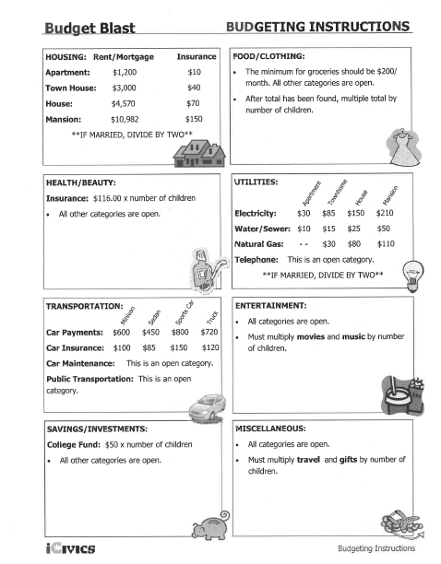
Step one: Circle one item in each line. In the career section there are two rows, just circle Medical, Legal, Education, Entertainment, Science and math, Service, or Business.

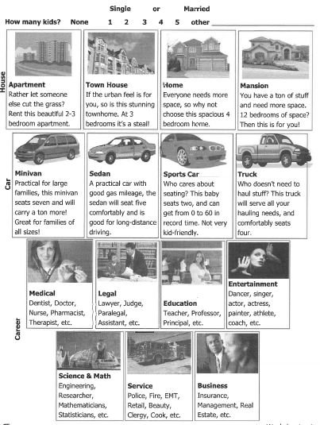
PAGE 1

Step Two: Find out how much you would make on average in your chosen career. Look back at the list provided.
Career: Salary:
Salary X % of Taxes = (Total taxes paid)
Salary - Total taxes paid = (Spendable income)

X 12 =
Monthly Budget Total yearly spending

PAGE 2

Monthly Budget
Step 4
Fill out this budget as best you can. You can/should ask your parent/guardian to help you. You may also use the internet. Remember this is for the entire month.
Housing  Rent/Mortgage: ___________________  Insurance: __________________  Home Repairs: ______________  Home Improvements: ____________  Home Goods: ______________  Add them all up  Total: ______________________________ | Food/Clothing  Groceries: ________________  Dining Out: _______________  Snacks: ___________________  Clothes: __________________  Shoes: ____________________ (be careful )  Add them all up  Total: _______________________________
Health/Beauty  Insurance: ______________________  Out of pocket expenses: __________________  Fitness: ____________________________  Grooming: ____________________________  Add them all up  Total: ________________________ | Utilities  Electricity: _______________________  Water/Sewer: _______________________  Natural Gas: ______________________  Telephone (Cell): ______________________  Add them all up  Total: ______________
Transportation  Car Payment: ______________  Car Insurance: ______________  Car Maintentance: _____________  Public Transportation (bus, taxi, Uber, lyft etc.) ________  Add them all up  Total: _______________________________ | Entertainment  Movies: __________________  Music: ________________  TV (cable, hulu, roku, etc): ________________________  Internet: ___________________  Computer (games, accessories, phone apps): _________  Add them all up  Total: ____________________________
Savings/Investment  Savings: ___________________  Retirement: __________________  Stocks/bonds: ________________  College Fund: _________________  Add them all up  Total: _______________ | Miscellaneous  Travel: __________________  Pets: ____________________  Gifts: ___________________  Donations: ______________  Other: _____________________  Add them all up  Total: _________________________

Add up all of the totals from each box.
Monthly Budget Total: ___________________________
PAGE 3
Now go back to page 2. Start under the Stop Sign with the stars around the sign. Put your monthly Budget Total on the line that says “Monthly Budget Total”.

Page 4

