The Enlightenment | Name:
A Time of New Ideas

The Enlightenment was a period of time when people developed new ideas about human existence, including peoples’ basic rights and the level of control they should have over their government and their futures. The Enlightenment began in Europe around 1715. People in cities like Paris gathered in salons to discuss philosophy and ways to improve the human experience. Many of their ideas were based in science and reason, which is why this time was also called the Age of Reason.

Natural Rights
Enlightenment thinkers believed that human beings are born with fundamental, basic
rights. These natural rights included the right to life, liberty, property, and the
freedom to find happiness. In order for people to enjoy these natural rights, other
rights needed to be protected. Enlightenment thinkers believed people should have the
right to express themselves, to move around freely, and to petition the government.
Locke
The Social Contract
If there was no government at all, people would live in a state of nature with no rules
and complete freedom—but without any protection from each other. One Enlightenment
idea was the social contract: citizens give up some freedom they would have in a state
of nature (like the freedom to rob and kill people), and in exchange the government
protects citizens’ right to life, liberty, and property. To Enlightenment thinkers, the
relationship between a government and its citizens was like an agreement. Citizens agree
to obey a set of rules, and the government agrees to protect citizens’ rights.
Rousseau
Consent of the Governed
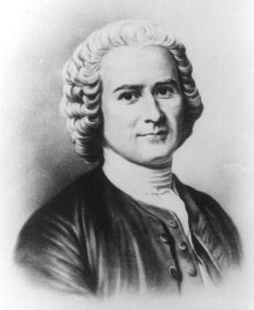
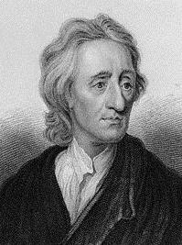

Enlightenment thinkers believed that governments had a responsibility to hold up their end of the social contract. If a government failed, then citizens would no longer agree to be governed and they would have the right to revolt. This idea is known as consent of the governed. Traditionally, a government protected citizens from foreign invaders, but the government also had absolute authority over the people. A king ruled his citizens whether they consented or not. To Enlightenment thinkers, this was unacceptable.

Republicanism

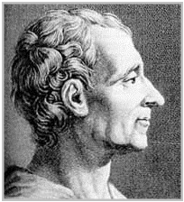
Since the Middle Ages, European leaders had gained power through heredity, or family ties. Kings and queens took the throne after another family member died. The people had no say in this process. Many Enlightenment thinkers believed in republicanism – the idea that a country’s leader should be chosen by the citizens in a general election. Even so, some Enlightenment thinkers frowned on the idea of a democracy. They feared what would happen if a mob of uneducated people had the power to vote.
Montesquieu
Influence on America

The brightest Enlightenment thinkers, with names like Rousseau, Montesquieu, and Locke, became very famous. They influenced leaders in Europe, and became popular with Americans who wanted independence. When our Founding Fathers created a government for the new United States, they embraced many Enlightenment ideas. America’s Constitution recognized that citizens were born with basic rights. And even though some of the Founders agreed with those concerned about democracy, the Constitution gave citizens the power to vote. The Enlightenment ended around 1789, about the same time the Constitution was born.

John Locke Name:

A Man with Many Hats
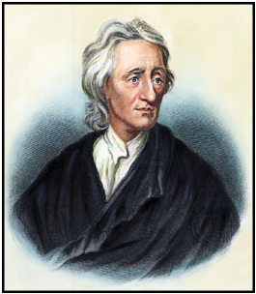

John Locke was born in England in 1632. Locke considered becoming a minister, started his career as a doctor, but ended up as a philosopher and political scientist. He had many interests and produced a number of writings that influenced future leaders. One of those leaders was Thomas Jefferson, who helped America gain independence from Britain nearly 150 years after Locke was born. Jefferson studied Locke’s writings, and Locke’s ideas show up in our own Constitution.

Experience

EXPOSURE to the World

The Blank Slate

One of Locke’s books, called An Essay Concerning Human Understanding, took over 18 years to write! In it, he says that people are born with a mind like a tabula rasa, which means a blank slate or page. During life, that blank slate gets filled up with the things a person experiences with the five senses. He said people learn and develop differently because they are exposed to different things. The one thing people have in common is that they are human and share a human nature that is the same for all people everywhere.

Natural Rights

Locke imagined a set of natural rights that human beings share. | People need:
These are the right to life, liberty, and property. Life refers to the fact | Life
that people want to live and will fight to survive. Liberty means that
people want to be as free as possible to make their own decisions. | Liberty
Property represents the fact that people want to own things that
help them survive, such as land, food, and tools. Locke believed these | Property
rights aren’t given to people—people are born with them.

Why do we need a government?
A GOVERNMENT CAN: |  | Locke also wondered what life would be like if people didn’t have a
Offer Protections |  | government. In this state of nature there would be no rules, no
 |  | one in charge, and no way for people to protect their natural
Provide Services |  | rights. He believed the purpose of government is to end the state
 |  | of nature and give people certain protections. Most importantly,
 |  | Locke believed governments should protect people’s natural rights.

Social Contract

Locke believed a government can only be legitimate, or valid, if it is based on a social contract with citizens. A contract is an agreement between people in which both sides agree to something in order to reach a shared goal. A social contract happens between a government and its people. The people agree to give up some freedoms if the government agrees to protect everyone’s rights. If the government fails to deliver, the people revolt—like the colonists did during the American Revolution.

GovernmentThe

PeopleThe

Baron de Montesquieu | Name:
A Baron is Born
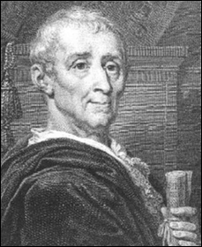

Charles Louis de Secondat was born in 1689 in the city of Bordeaux, France. At age 27, he became Baron de Montesquieu (MON-teh-skew) when he inherited his uncle’s fortune and title. Montesquieu was one of the great thinkers of the 17th and 18th centuries. He spent a lot of time thinking about how governments should be created and maintained. His ideas guided the Founding Fathers when they wrote the United States Constitution. Even today, Montesquieu’s thinking influences the way people think about government around the world.

How do the laws in our society keep us safe?

_{Follow the Rules} Baron de Montesquieu

The term liberty means different things to different people. Some think liberty means being able to speak and act without being held back by laws and rules— in other words, being able to do whatever you want. But Montesquieu believed that liberty is the peace of mind that comes from being safe. He believed safety can only exist if everyone follows the law. If governments could provide and enforce clear laws that everyone would follow, it would increase liberty, reduce the problems of society, and improve human life.
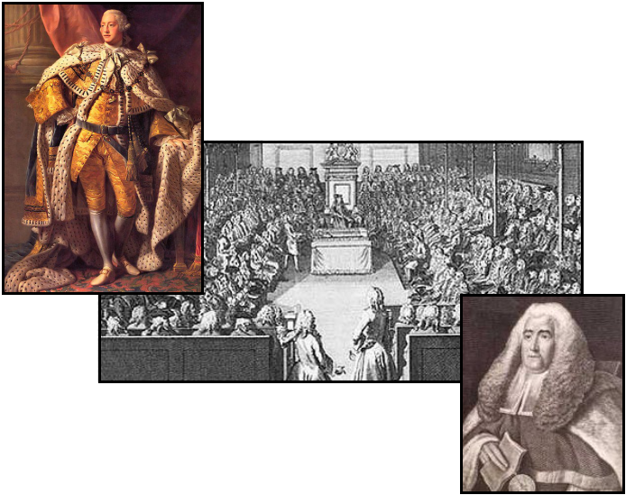

Separate...

Montesquieu studied the laws, customs, and governments of European countries to see how they created and enforced laws. He admired the government of England. The English government had three parts: a king to enforce laws, Parliament to create laws, and courts to interpret laws. The government was divided into parts, and each part had its own purpose. Montesquieu called this the separation of powers.

…but Equal
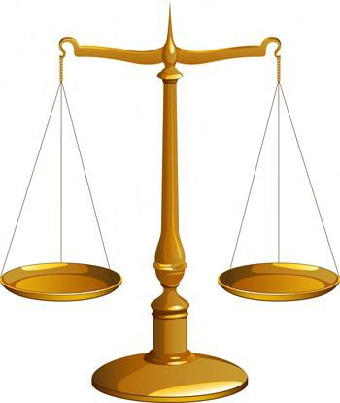

- King George III

House of Commons ↓

Sir William Blackstone, an → 18th century English judge

Dividing the powers of government was just the first step. Each part of the government needed to be balanced with the other parts. Montesquieu thought that each of the parts, or branches, of government should be equal. He worried that if one branch had more power than the others, people would suffer and lose their liberty. To avoid this, he suggested that each branch have the ability to limit the power of the other two branches. In England, if the king tried to take too much control, the Parliament or the courts could act to stop him. Today, we call this the system of checks and balances.

Sound Familiar?
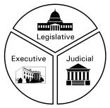

James Madison, the “Father of the Constitution,” liked the idea that each branch of government should have a clear role. As a result, the U.S. Constitution clearly explains what each branch is supposed to do: Congress makes laws, the President enforces laws, and the Courts interpret laws. Each branch has the power to check, or limit, the other branches. This keeps all branches of government balanced and equal.

