Civics

Grade 7 Social Studies

Week 4: April 20- April 24

Your Week at a Glance

Daily Schedule (Suggested)
Day 1:
International Organizations Online Activity and Questions

Day 2:
International Organizations Reading and Chart

Day 3
International Organizations Reading and Chart

Day 4
International Organizations Reading and Chart

Day 5:
Finish International Organizations Reading and Chart

Name Date International Organizations- Florida Students Online Directions:
You will need headphones.
-Go to http://www.floridastudents.org
-Choose Social Studies
-Choose Civics
-Choose Recognize government and citizen participation in international organizations. (Standard #: SS.7.C.4.2) (At the end.)

International Organizations
- What does international mean?

- What is an intergovernmental organization?

NAFTA
- What does NAFTA stand for?
- When was it founded?
- What three countries are involved?
- What is the purpose of NAFTA?

WTO
- What does WTO stand for?
- When was it founded?
- How many countries are involved?
- What is the purpose of WTO?

- How are NAFTA and the WTO similar?

NATO
- What does NATO stand for?
- When was it founded?
- How many countries are involved?
- What is the purpose of NATO?

- What was happening with the USA and Soviet Union to spark the creation of NATO?

UN
- What does UN stand for?
- When was it founded?
- How many countries are involved?
- What is the purpose of UN?

- What are the two parts of the United Nations?

- How many countries are part of the UN Security Council?
World Court
- When was it founded?
- How many countries are involved?
- What is the purpose of World Court?

UNICEF
- What does UNICEF stand for?
- When was it founded?
- How many countries are involved?
- What is the purpose of UNICEF?

- Who does UNICEF focus on helping?
- List three things UNICEF might do to help people of the world

Red Cross
- True or False. The Red Cross relies on volunteers.
- The Red Cross helps during situations.

Use your certificate at the end record you Time Started time completed .

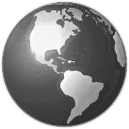
International Organizations Name:
Working Together
Organizations are groups of people, businesses, or governments that work together to solve an issue. International organizations involve governments or people from different countries working together to solve an issue that crosses country borders. Reaching across borders is what makes them
“international.” There are two main types of
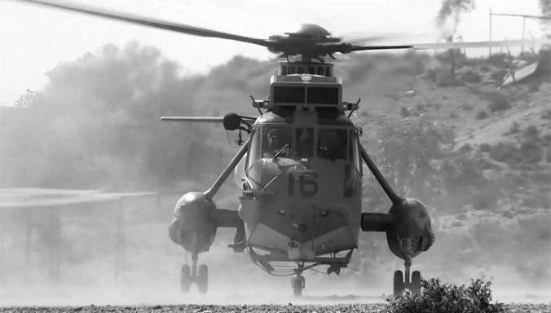
international organizations.

Intergovernmental Organizations
“Inter” means among or between. It is a prefix that shows there is a connection between things Intergovernmental organizations are organizations that are formed between governments. They are based on formal agreements between three or more countries that have come together for a specific purpose. For example, several governments might come together to help defend each other against enemy threats. Or, governments
might form an organization to solve an environmental problem that is affecting each nation involved.

In 2015, the North Atlantic Treaty Organization (NATO) began testing a new “Very High Readiness Joint Task Force.” The VHJT will be a multinational brigade that can deploy 5,000 troops within 48 hours.

Nongovernmental Organizations

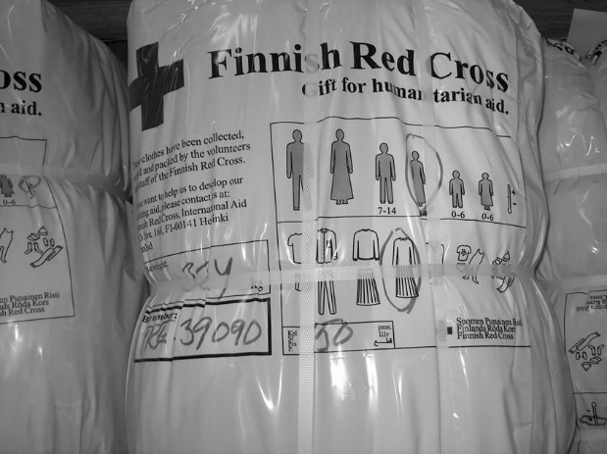
“Non” means not. Nongovernmental organizations (NGOs) are groups that work to solve problems around the world but are not connected to any government. (Although they may have members that come from government organizations.) NGOs must raise money independently to fund their projects, so are free to work toward their own goals. They don’t rely on a government to make decisions or provide support, although many NGOs do receive government funding. NGOs often work together, especially if they have similar goals or focus on the same geographical region. For example, if an NGO wanted to
A bundle of clothes from the Red Cross in Finland fight disease in central Africa, it might collaborate with other
waits to be donated to people in need. NGOs working in that area.

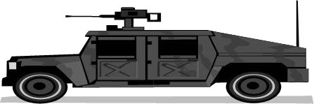
What International Organizations Do
International organizations are generally involved in either aid or security. Imagine that terrorist breaks out in a small corner of the world. The countries involved have weak governments and little money, and the trouble is turning into a crisis. Thousands of people are suffering. Some international organizations may send military

forces to help restore peace or advisers to help strategize against the terrorists. Other organizations may send food or medical supplies to help suffering civilians. In this way, international organizations are critical to keeping the world a safe and stable place to live.

Directions: Use the reading to answer the following questions.

- What is an intergovernmental organization?

- Give one example of an intergovernmental organization might do.

- What is a Non-governmental organization (NGO)?

- Provide one example of what a non-governmental organization might do.

- Is NATO an intergovernmental organization or a nongovernmental organization? (Use the picture and caption to infer.)
What evidence led to your decision?

- Is Red Cross an intergovernmental organization or a nongovernmental organization? (Use the picture and caption to infer.)
What evidence led to your decision?

- What do international organizations do?

- Provide one example of what an international organization might do.

The United Nations

In October 1945, right after World War II, fifty-one countries started an organization with a goal of keeping peace, developing friendly relationships among countries, and improving the quality of life for the world’s poor people. This organization, called the United Nations (UN), has 193 member nations today.
In its peacekeeping role, the UN sends troops to bring stability and peace to troubled areas of the world. UN peacekeepers are troops or police sent from member countries. They wear their own country’s uniform with a UN helmet or beret. One of the UN’s peacekeeping missions is in the Democratic Republic of the Congo, a country in Africa where tribes and smaller militias have been fighting for years. UN peacekeepers are there to protect civilians and aid workers from physical violence. They are also helping the country’s government restore the rule of law. The UN currently has 15 similar missions around the world.
In its role to improve the quality of life for the world’s poor, two of the most well-known UN organizations are the United Nations
Children’s Fund (UNICEF) and the World Food Programme (WFP). UNICEF works in poor areas of the world to help prevent disease and child abuse. UNICEF also support the rights and education of children, especially girls, who do not receive equal treatment to boys in many parts of the world. The WFP works to end hunger around the world. Part of this involves bringing food when there is an emergency. The other part involves preventing hunger in poor parts of the world. The WFP does this by providing school meals to encourage families to keep their kids in school, helping farmers find good markets for selling their products, and paying people with food in exchange for their labor building improvements to their communities.
Name:
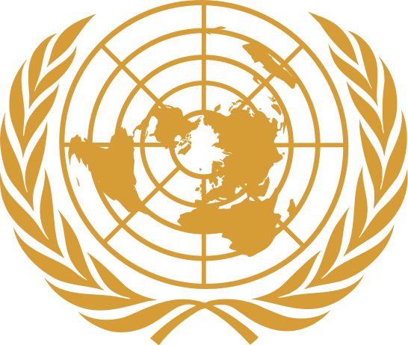
Your Report
Follow the directions and answer the questions below, then explain to your group what the United Nations is all about.

Read. Read the article through one time so you know what’s there.

Mark It Up.
- Circle the year the United Nations was founded and the number of countries involved today.
- Underline the main purpose of the United Nations. (This could be the reason why it was started or its main goal.)
- the two main roles of the United Nations.
Box
- Put [brackets] around one example for each role.

Take Notes. You will use these when you tell your group about the United Nations.
The United Nations was founded in .
countries are involved today.
The reason the United Nations exists is to

. The United Nations has two roles:
1.
2. A good example of something the United Nations does is

Presentation Activity—UN

North Atlantic Treaty Organization

The North Atlantic Treaty Organization (NATO) is a group of countries in Europe and North America that have signed a treaty agreeing to protect each other in case of attack. NATO was founded in April 1949 by twelve countries. Today, NATO has 28 member countries. NATO countries protect themselves by working together to help stabilize parts of the world that are in trouble.
One role of NATO countries is to help keep peace and security around the world, even in non-member countries. For example, NATO troops are in Afghanistan helping the government there to maintain control of the country and fight the threat of terrorism. In addition, NATO troops in both Afghanistan and Iraq are helping to train the militaries in those countries to be able to stand on their
own. In another part of the world, “Operation Ocean Shield” uses naval ships from NATO countries to fight pirates and provide security to ships off the Horn of Africa.
NATO also uses its resources to help both member countries and non-member countries after a natural disaster. It does this because it believes the world will be more safe and secure if victims of natural disaster receive help quickly. For example, in 2010 Pakistan suffered major flooding and asked NATO for help. NATO agreed to deliver donations from countries and nongovernmental organizations. NATO airplanes delivered many supplies from member countries: generators, water pumps, and tents donated from Slovakia; food and medical supplies donated by Germany; field hospitals from Denmark; and blankets and tents from France, as well as baby food and high energy biscuits from nongovernmental organizations along with other aid donations.
Name:
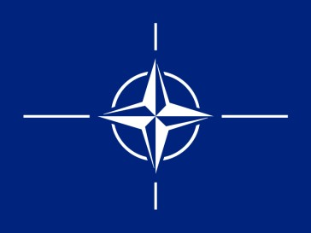
Your Report
Follow the directions and answer the questions below, then explain to your group what the North Atlantic Treaty Organization is all about.

Read. Read the article through one time so you know what’s there.

Mark It Up.
- Circle the year NATO was founded and the number of countries involved today.
- Underline the main purpose of NATO. (This could be the reason why it was started or its main goal.)
- the two main roles of NATO.
Box
- Put [brackets] around one example for each role.

Take Notes. You will use these when you tell your group about the NATO.
The North Atlantic Treaty Organization was founded in .
countries are involved today.
The reason NATO exists is to

.
NATO has two roles:
1.
2. A good example of something NATO does is

Presentation Activity—NATO

The European Union

The European Union (EU) is a partnership between countries in Europe that is designed to help them avoid conflict by making them dependent on each other. The EU began in 1951 with a treaty between six countries who agreed to operate their coal and steel industries together. This way, none of the six could manufacture its own weapons to use against the others in war. Later, the six countries began to adopt the same economic rules, such as paying farmers in all countries the same for their produce. They also allowed goods to be traded between the six countries without any taxes for moving products across borders. The idea was that countries that depended on each other would be less likely to go to war against each other. Today, the EU has 27 member countries.
One role of the EU is to create a single economy in which all of the members participate. All of the countries use the same unit of money, called the Euro. Goods trade freely between the member countries without being taxed.
Another role of the EU is to act as a single voice in the world for its member countries. The EU is run by a European government that is made up of representatives voted into office by citizens in the 27 countries. The government of the EU makes decisions about what the EU as a group will do about a wide variety of issues, such as terrorism. By acting as one unit, the members have more influence than they would if they each acted alone. For example, the EU might use its influence to negotiate peace between countries in conflict.
Finally, the EU plays a major role giving aid to countries around the world that have problems such as hunger, disease, and environmental contamination. For example, the EU keeps aid workers in the Caribbean to help people in those countries develop better ways to cope with natural disasters such as hurricanes and earthquakes. The EU is also actively distributing food to people in the poorest countries of Africa.
Name:

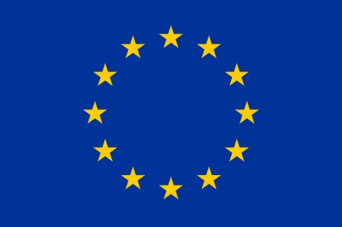
Your Report
Follow the directions and answer the questions below, then explain to your group what the European Union is all about.

Read. Read the article through one time so you know what’s there.

Mark It Up.
  - Circle the year the European Union was founded and the number of countries involved today.
  - Underline the main purpose of the European Union. (This could be the reason why it was started or its main goal.)
  - the two main roles of the European Union.
Box
  - Put [brackets] around one example for each role.

Take Notes. You will use these when you tell your group about the European Union.
The European Union was founded in . countries are involved today.
The reason the European Union exists is to

. The European Union has three roles:
1.
2.
3. A good example of something the European Union does is

Presentation Activity—EU

The World Health Organization

The World Health Organization (WHO) is an organization within the United Nations that works to improve health around the entire world. It does this not only by providing health care in poor areas, but also by conducting research in order to wipe out disease and by helping countries develop their health care systems. The WHO was started by the United Nations on April 7, 1948. April 7 is now known as “World Health Day.” The United Nations has 193 member countries today.
One important role of the WHO is to gather data about health around the world. It compiles statistics about things like the leading causes of death in different areas of the world and how often certain diseases occur. It even keeps track of smoking in different parts of the world. Tracking these kinds of data helps the WHO understand what needs to be done to help people. The WHO data also helps researchers in individual countries, where much of the medical research in the world takes place.
Another role of the WHO is to help keep people healthy around the world. The WHO sponsors many health programs. Some of these programs focus on wiping out specific diseases, such as dengue, a deadly flu-like virus transmitted by mosquitoes in tropical areas of the world. The WHO helps prevent this disease through programs that control the spread of mosquitoes and by conducting research. The WHO also makes sure as many children as possible in the world have been immunized against diseases such as whooping cough, measles, and tuberculosis. The WHO’s aggressive Global Polio Eradication Initiative has wiped out polio from much of the world.
The WHO also plays a role responding to crises around the world. For example, the WHO has set up a rehydration center to help people dehydrated from drought in Yemen. Drought also leads to malnutrition, because food cannot grow without water. When there is a famine, the WHO treats medical complications that result from severe malnutrition and helps fight disease in communities weakened by lack of food.
Name:
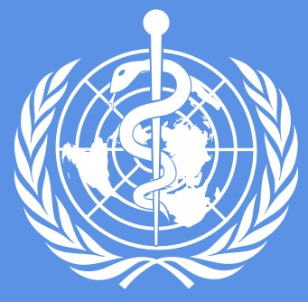
Your Report
Follow the directions and answer the questions below, then explain to your group what the World Health Organization is all about.

Read. Read the article through one time so you know what’s there.

Mark It Up.
- Circle the year the World Health Organization was founded and the number of countries involved today.
- Underline the main purpose of the WHO. (This could be the rea- son why it was started or its main goal.)
- the two main roles of the WHO.
Box
- Put [brackets] around one example for each role.

Take Notes. You will use these when you tell your group about the World Health Organization.
The World Health Organization was founded in .
countries are involved today.
The reason the WHO exists is to

. The World Health Organization has three roles:
1.
2.
3. A good example of something the WHO does is

Presentation Activity—WHO

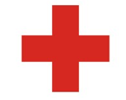

The Red Cross and Red Crescent Societies
The International Red Cross and Red Crescent Societies work to help people around the world. (Islamic countries usually have a red crescent instead of a red cross.) Currently 186 countries have societies. The first Red Cross society was formed in 1863 in Geneva, Switzerland, by five men who wanted to organize volunteers who could help wounded soldiers during wartime.
Today, the Red Cross and Red Crescent societies do much more than help wounded soldiers. One of the main roles of these societies is to respond to disasters. For example, the American Red Cross acted immediately to help victims of the September 11 terrorist attacks.
The Red Cross set up emergency medical clinics and helped victims and families try to contact each other. In another example, in August 2011 there was a shipwreck near the island nation of Comoros off the east coast of Africa. The Comoros Red Crescent society offered first aid, helped identify the remains of people killed, and supported the families of survivors and their families.
Each country has its own society, so another role of the Red Cross and Red Crescent societies is to run programs in their local communities. For example, the Red Crescent in the capitol of Kyrgyzstan runs a school for street children with help from the Netherlands Red Cross. In Thailand, where drug offenders often spend decades in prison, the Thai Red Cross Society helps prisoners stay healthy while in jail and learn to adjust to life once they are released. In Australia, young volunteers from the Australian Red Cross go out to parties and dance clubs to educate other young people about the dangers of drugs and alcohol.
Finally, people from the Red Cross and Red Crescent play a very important role in visiting prisoners of war and civilians who are imprisoned during times of conflict. The Red Cross and Red Crescent checks to see whether the prisoners are being treated humanely as required by an international treaty called the Geneva Convention.
The Red Cross and Red Crescent also helps them communicate with their families, if possible.
Name:

Your Report
Follow the directions and answer the questions below, then explain to your group what the Red Cross and Red Crescent are all about.

Read. Read the article through one time so you know what’s there.

Mark It Up.
- Circle the year the Red Cross was founded and the number of countries involved today.
- Underline the main purpose of the Red Cross/Red Crescent. (This could be the reason why it was started or its main goal.)
- the two main roles of the Red Cross/Red Crescent.
Box
- Put [brackets] around one example for each role.

Take Notes. You will use these when you tell your group about the Red Cross/Red Crescent.
The Red Cross/Red Crescent was founded in .
countries are involved today.
The reason the Red Cross/Crescent exists is to

. The Red Cross/Red Crescent has three roles:
1.
2.
3. A good example of something the Red Cross/Crescent does is

Presentation Activity—Red Cross

The World Bank
The World Bank is an organization that helps poor and middle- income countries get the money they need to build improvements that will help reduce poverty. The World Bank was founded in 1944. Today, it is owned by 187 member countries. There are two main organizations within the World Bank, each with its own role.
One role of the World Bank is to improve the living conditions in countries with moderate financial resources. The International Bank for Reconstruction and Development (IBRD) is the part of the World Bank that does this. The IBRD helps middle-income countries figure out what their needs are and what strategies will work best. Then, the IBRD helps these countries get loans or other kinds of financial aid to build programs that will help. For example, the government of Mexico needed to increase energy efficiency in Mexico, but it could not succeed unless its poorest people participated. The IBRD helped Mexico start a program that gives out free fluorescent bulbs and gives people discounts for replacing their old appliances. In Costa Rica, the IBRD helped with special financing that lets the country get money to deal with natural disasters without taking money away from other important projects.
Another role of the World Bank is to improve conditions in the poorest countries in the world. The International Development Association (IDA) is the part of the World Bank that does this. The IDA helps poor countries by giving them grants of money or loans with no interest. The countries use this money to improve their citizens’ living conditions and to improve economic growth in the country. For example, in 2008 there was a dramatic increase in food prices in Ethiopia. The IDA helped Ethiopia buy fertilizer for the 2009 growing season. This helped the farmers produce more food the next year, which lowered prices. In Vietnam, the IDA has helped people have access to clean water by providing money to develop new water sources and to reconstruct old water distribution systems.
Name:
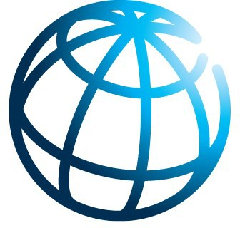
Your Report
Follow the directions and answer the questions below, then explain to your group what the World Bank is all about.

Read. Read the article through one time so you know what’s there.

Mark It Up.
- Circle the year the World Bank was founded and the number of countries involved today.
- Underline the main purpose of the World Bank. (This could be the reason why it was started or its main goal.)
- the two main roles of the World Bank.
Box
- Put [brackets] around one example for each role.

Take Notes. You will use these when you tell your group about the World Bank.
The World Bank was founded in .
countries are involved today.
The reason the World Bank exists is to

. The World Bank has two roles:
1.
2. A good example of something the World Bank does is

Presentation Activity—World Bank

WHO- The World Health Organization
The World Health Organization is a specialized agency of the United Nations that is concerned with international public health. It was established on April 7, 1948 headquartered in Geneva, Switzerland .

Our primary goal is to build a better, healthier future for people all over the world. Working through offices in more than 150 countries, WHO staff work side by side with governments and other partners to ensure the highest attainable level of health for all people. This first goal is our effort to combat diseases – infectious diseases like influenza and HIV and non- communicable ones like cancer and heart disease. We help mothers and children survive and thrive so they can look forward to a healthy old age.

A second goal or objective of WHO is to promote the physical, mental, and social well-being, of people not just prevent the spread of disease. For example, they ensure the safety of the air people breathe, the food they eat, the water they drink – and the medicines and vaccines they need.

Recently the WHO has worked to prevent the spread of malaria, a disease spread by mosquitoes. WHO has been working with NCDC and other partners to control Lassa fever in Nigeria by
Your Name
Follow the directions and answer the questions below, be prepared to explain to the class what your organization is all about.

READ. Read the article through one time so you know what is there.
Mark it Up.
  - Circle the year the World Heath Organization was founded and the number of countries involved today.

  - Underline the main purpose of the WHO. (This could be the reason it was started or its main goal.)

  - Box the two main roles of WHO.

  - Put [brackets] around one example for each role.

Take Notes. You will use these to create your poster for your class presentation.
The World Health Organization was founded in .
countries are involved today.
The reason WHO exists is to

deploying teams to hotspots, identifying and treating patients,
strengthening infection, prevention and control measures in

health facilities, and engaging with communities. They are also working to control the spread of cholera in Somalia. Cholera is a bacterial disease spread through water that contains bacteria. In addition to these efforts, the World Health Organization (WHO), UNICEF and national health authorities have completed
What are two roles of WHO?
1.
2.
One example of something WHO does
is

a large-scale vaccination campaign to control the spread of
diphtheria in Yemen.

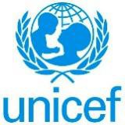
UNICEF -United Nations International Children's Emergency Fund

UNICEF is mandated by the United Nations
General Assembly to advocate for the protection of children's rights, to help meet their basic needs and to expand their opportunities to reach their full potential.

UNICEF is guided by the Convention on the Rights of the
Child and strives to establish children's rights as enduring ethical principles and international standards of behavior towards children.

UNICEF was created in 1946 after the Second World War by the United Nations to provide food, clothing and health care to European children. UNICEF Lebanon was established shortly after, in 1948. The office was the first field operation office outside UNICEF’s headquarters. There are 150 countries that participate.

In Lebanon, UNICEF was the only UN agency working during the many years of the civil war, providing key assistance in health, water and sanitation as well as demining in many parts of the devastated country.

One of the key challenges facing the children of Lebanon today is
Your Name
Follow the directions and answer the questions below, be prepared to explain to the class what your organization is all about.

READ. Read the article through one time so you know what is there.
Mark it Up.
  - Circle the year the UNICEF was founded and the number of countries involved today.

  - Underline the main purpose of UNICEF. (This could be the reason it was started or its main goal.)

  - Box the two main roles of UNICEF.

  - Put [brackets] around one example for each role.

Take Notes. You will use these to create your poster for your class presentation.
The UNICEF founded in . countries are involved today.
The reason UNICEF exists is to

that many years after reconstruction from conflict, they continue to
live in the shadow of internal political instability. UNICEF Lebanon is committed to ensuring that all its activities address the impact of

this situation on children.

UNICEF is working in many countries around the world to help children get access to safe places to live and clean water. Now in its 6th year, the ongoing conflict has left 6 million children in Syria in urgent need of life-saving assistance and has left more than 4
What are two roles of UNICEF?
3.
4.
One example of something UNICEF does
is

million Syrians living as refugees. As the humanitarian situation in
Yemen worsens by the day, some 21 million people - 80 percent of the entire population - require humanitarian aid. Almost 20 million people do not have access to clean water and more than 3 million children under 5 are at risk of severe acute malnutrition.

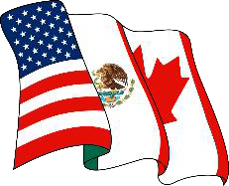
NAFTA- North American Free Trade Agreement
The North American Free Trade Agreement(NAFTA) was negotiated among the
United States, Canada and Mexico for the purpose of removing barriers to the exchange of goods and services among the three countries. It was established in 1994. Trade barriers began dropping as of Jan. 1, 1994, and were completely eliminated on schedule by Jan. 1, 2008.

Among its main goals is increased trade between Canada, Mexico and the United States, stimulate economic growth and give the NAFTA countries equal access to each other's markets.
The NAFTA partners negotiated and implemented a parallel agreement on labor cooperation, the North American Agreement on Labor Cooperation (NAALC). The NAALC adds a social dimension to NAFTA. Through the NAALC, the regional trading partners seek to improve working conditions and living standards, and to protect, enhance, and enforce basic workers’ rights.
Over the years, NAFTA has helped to improve working conditions and living standards in Canada, the U.S., and Mexico. It has also raised the public profile of major labor rights issues, including pregnancy-based discrimination, secret ballot voting,
Your Name
Follow the directions and answer the questions below, be prepared to explain to the class what your organization is all about.

READ. Read the article through one time so you know what is there.
Mark it Up.
  - Circle the year NAFTA was founded and the number of countries involved today.

  - Underline the main purpose of the NAFTA. (This could be the reason it was started or its main goal.)

  - Box the two main roles of NAFTA.

  - Put [brackets] around one example for each role.

Take Notes. You will use these to create your poster for your class presentation.
The NAFTA was founded in . countries are involved today.
The reason NAFTA exists is to

protection contracts, and protection of migrant workers.
NAFTA promotes the effective enforcement of domestic labor

laws in all three countries and highlights cooperation on labor matters in three key areas: industrial relations, occupational health and safety, and employment standards.
In addition, NAFTA has promoted higher wages. In Mexico, for example, export firms employ one in five workers; these workers
What are two roles of NAFTA?
5.
6.
One example of something NAFTA does
is

are paid 40% more on average than those in non-export jobs.
Firms with foreign direct investment employ nearly 20% of the labor force and pay 26% more than the domestic average manufacturing wage.

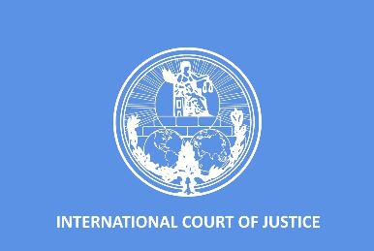
World Court – International Court of Justice
The 15-member ICJ, or World Court, is the principal judicial organ of the United Nations, seated at The Hague in the Netherlands in the Peace Palace. All 193 members of the United
Nations participate. The World Court settles legal disputes submitted to it by states and giving advisory opinions on legal questions from U.N. bodies and agencies. It has the jurisdiction to prosecute individuals for the international crimes of genocide, crimes against humanity, and war crimes. It was established through the adoption of the UN Charter and Statute of the ICJ in 1945, after World War II.
War crimes are defined in the statute that established the International Criminal Court, which includes: Grave breaches of the
Geneva Conventions, such as: Willful killing, or causing great suffering or serious injury to body or health. Torture or inhumane treatment.
The term “crimes against humanity” was used for the first time in 1915 by the Allied governments (France, Great Britain and Russia) when issuing a declaration condemning the mass killings of Armenians in the Ottoman Empire. However, it was only after World War II in 1945 that crimes against humanity were for the first time prosecuted at the International Military Tribunal (IMT) in Nuremberg.
One example is searching for people who have committed crimes of humanity such as Joseph Kony of the leader of Uganda's Lord's Resistance Army. Kony and other leaders of the LRA, a guerrilla group
Your Name
Follow the directions and answer the questions below, be prepared to explain to the class what your organization is all about.

READ. Read the article through one time so you know what is there.
Mark it Up.
  - Circle the year the World Court (ICJ) was founded and the number of countries involved today.

  - Underline the main purpose of the World Court (ICJ). (This could be the reason it was started or its main goal.)

  - Box the two main roles of the World Court( ICJ).

  - Put [brackets] around one example for each role.

Take Notes. You will use these to create your poster for your class presentation.
The World Court (ICJ) was founded in _.
countries are involved today.
The reason World Court exists is
to

that began a violent campaign against the Ugandan government in 1986,
have been indicted by the International Criminal Court for crimes against humanity and war crimes.

The rebels have been accused of, among other atrocities, cutting off the tongues and lips of civilians and abducting thousands of children, turning the girls into sex slaves and the boys into child soldiers.

Kony was indicted in The Hague in 2005. In October 2011, the U.S. sent 100 special forces soldiers to help Uganda track down Kony. He has
What are two roles of World Court?
7.
8.
One example of something World Court has done
is

evaded capture, but reports say his health is failing.

International Organizations Name Directions: Use the readings to complete the following chart.
The World Trade Organization (WTO)  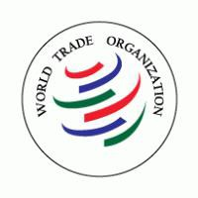 | Reason the World Trade Organization exists: | Main Roles of the WTO: | Example of what the WTO does:
Year Founded: Current Number of Countries
Involved:
The United Nations (UN) | Reason the United Nations exists: | Main Roles of the UN: | Example of what the UN does:
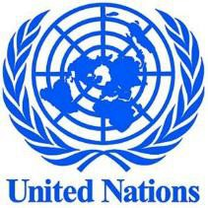
Year Founded: Current Number of Countries
Involved:
The World Health Organization (WHO) | Reason the WHO exists: | Main Roles of the WHO: | Example of what the WHO does:
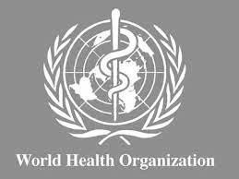
Year Founded: Current Number of Countries
Involved:

UNICEF | Reason UNICEF exists: | Main Roles of UNICEF: | Example of what UNICEF does:
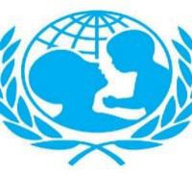
Year Founded: Current Number of Countries
Involved:
The Red Cross and Red Crescent | Reason the Red Cross exists: | Main Roles of the Red Cross: | Example of what the Red Cross does:
Year Founded: Current Number of Countries
Involved:
World Court  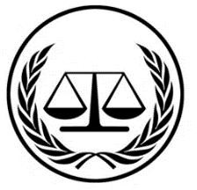 | Reason the World Court exists: | Main Roles of the World Court: | Example of what the World Court does:
Year Founded: Current Number of Countries
Involved:

North American Trade Agreement (NAFTA) | Reason NAFTA exists: | Main Roles of NAFTA: | Example of what NAFTA does:
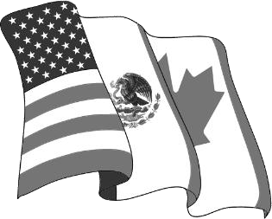
Year Founded: Current Number of Countries
Involved:
North Atlantic Treaty Organization (NATO) | Reason NATO exists: | Main Roles of NATO: | Example of what NATO does:
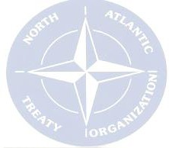
Year Founded: Current Number of Countries
Involved:
European Union (EU) | Reason EU exists: | Main Roles of EU: | Example of what EU does:
Year Founded: Current Number of Countries
Involved:

