Civics

Grade 7 Social Studies

Week 6: May 4 - May 8

Your Week at a Glance

Daily Schedule (Suggested)

Day 1:

Chapter 13/14 Definition Depot

Day 2:

Chapter 13/14 Definition Depot

Day 3

Great State Reading and Questions

Day 4

Great State Reading and Questions

Day 5:

Great State Reading and Questions

Additional Support:
CPalms: www.floridastudents.org

Directions for accessing:

- Go to floridastudents.org
- Choose Social Studies
- Choose Civics
- Choose the activity you want to complete. See below.
- On the right hand side, click the tab that reads “captions” to read along.
-Differentiate between local, state, and federal governments' obligations and services. (Standard #: SS.7.C.3.14)
-Illustrate the law making process at the local, state, and federal levels. (Standard #: SS.7.C.3.9)

Name: ________________________________________________ Date: ___ Per.: _
Civics Definition Depot – Chapter 13/14
Directions: Each definition should come from the textbook using the page provided or from online. Using a thesaurus, your brain, help from a parent identify at least one synonym (words that mean the same thing) for each term OR provide a colored illustration that shows that you understand the meaning of the term OR write a sentence using the term that makes sense and demonstrates your understanding of the word.
Word/Pg. # |  | Definition | Sentence, Synonym, or Illustration
Delegated/
Enumerated powers
p. 140

Reserved powers
p.140

Concurrent powers
p.140

Constituent
p.198

Initiative
p. 316

Governor | the elected executive head of a state
Statutes
p.414

Municipality  p. 387 |  |  | City
County
p. 394
Charter | legal document establishing a municipality such as a city or town
Town
p. 399
Ordinances
p. 388
Mayor
p. 388
City council
p. 388
Commission | Elected officials meeting in groups of 5-7 that hold the legislative and executive power in a city
School Board | Elected officials that govern the day-to-day operations of K-12 public education

Name: _________________________ Date: ________________ Period: ____
Chapter 13 – “State Government”
Vocabulary Quiz
Matching: Match the definition of the concept to the term. Write the letter of your answer choice on the line provided.
_____ 1. Bicameral A. This term refers to the chief executive of state government
_____ 2. Constituent B. Two-house legislature
_____ 3. Initiative C. Laws written by the legislature
_____ 4. Unicameral D. One-house legislature
_____ 5. Governor E. Citizens who legislators represent
_____ 6. Statutes F. Citizens start legislation through this process

Venn Diagram: Using your knowledge of Civics and of the relationship between federal and state government, complete the following Venn diagram.
Powers of Government
9. _______________
State
7. _______________
Federal
8. _________
Shared
Fill in the Blank: Write the term that best completes the sentence.
10. In all cases except for those involving federal law, the decisions of state __________________
(district courts / supreme courts) are final.
Chapter 14 – “Local Government”

Fill in the Blank: Write the term that best completes the sentence.
11. ___________________ (block grants/grants-in-aid) are federal fuds given to state and local governments for specific projects.
12. _________________ (charter/ordinance) is the constitution or basic plan for local governments
13. _________________ (local/state) governments often provide services like sidewalks, running water, and garbage collection.
Picture It: Examine the images below. Using your knowledge of Civics and the local government, circle the term that is best represented by the image.

#14 | Ordinance  Communication  Public Utility  Recreation | 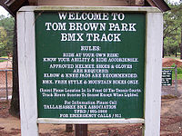  #15 | Ordinance  Communication  Public Utility  Recreation
#16 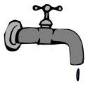 | Ordinance  Communication  Public Utility  Recreation | #17 | Ordinance  Communication  Public Utility  Recreation

Matching: Match the definition of the concept to the term. Write the letter of your answer choice on the line provided.
_____ 18. Town A. is the legislative body in mayor-council form of government
_____ 19. County B. an elected official who arrests lawbreakers and carries out orders of county courts
______ 20. City C. a unit of local government
______ 21. Municipality D. the largest unit of local government
______ 22. City Council E. a form of local government where three to nine elected officials act as the legislative body
______ 23. Mayor F. unit of local government that is larger than a village and smaller than a city
______ 24. Commission G. city’s chief executive officer
______ 25. Sheriff H. the highest level of local government

The Great State Name:

State Government: Sound Familiar?
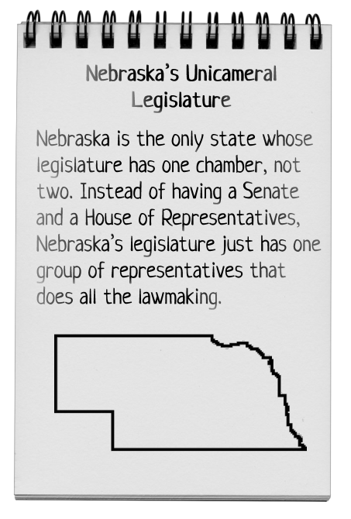

State governments work almost exactly like the federal government. There are three branches of government: an executive branch, a legislative branch, and a judicial branch. At the state level, the head of the executive branch is called the governor. Every state except one also has a bicameral legislature, meaning that the legislature is made up of two chambers. In most states, those chambers are called the Senate and the House of Representatives. A state’s judicial branch normally includes a high court, often called the Supreme Court, and a system of lower courts. These lower courts include trial courts and appeals courts.

A state’s three branches interact just like the three branches at the federal level. The purpose of having three branches is to balance power so that no one branch or person becomes too powerful. The state’s legislature passes laws. A state’s governor can veto laws that are passed, and a state’s high court has the power to decide whether state laws violate the state’s constitution.
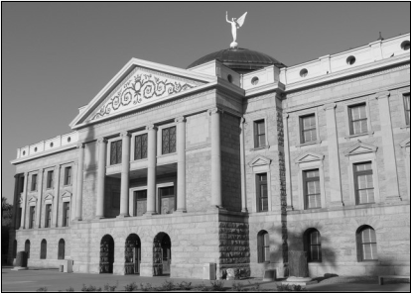

Many state legislatures have outgrown their historic buildings, such as this state capitol building in Arizona.

The State Legislative Branch

The state legislature is the state’s lawmaking body. The state’s legislators are the state’s lawmakers. Each state is divided into legislative districts that contain roughly the same number of citizens. Citizens in each district elect representatives to serve in the state legislature. That means the state legislators represent the citizens who live in their district. This way, the interests of people in different parts of the state can be represented when state laws are being considered.
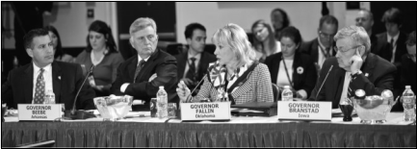

The State Executive Branch

The head of a state’s executive branch is the state governor. The governor is like the “president” of a state and has similar powers, such as the power to veto bills passed by the state’s legislature. A state’s executive branch also includes many departments. States usually have their own departments of education, transportation, health, and other services. These departments carry out the laws passed by the state’s legislature.

Governors from each state belong to the National Governors Association and meet twice each year to discuss issues that affect all states.

The State Judicial Branch

At the state level, like the federal level, cases start in a trial court. In many states, the trial-court level is called the superior court. States also have appeals courts where people can fight a trial court’s ruling. And, of course, every state has a high court. A state’s high court reviews the decisions made by lower courts, supervises the other courts, and interprets the state constitution as it applies to the law. State judicial branches also include a level of courts below the trial courts. These courts handle the thousands of smaller issues that come up every day, such as traffic tickets and minor crimes called misdemeanors.
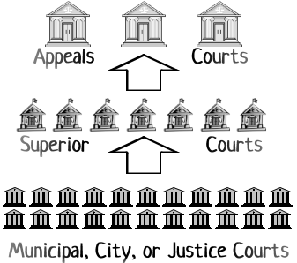

Reading p.1

The Great State Name:

The New York Assembly

State Laws

The state legislature is a state’s lawmaking body. But in all states, the “law of the land” is the state constitution. Just like the U.S. Constitution, a state’s constitution describes how the state’s government must operate. It may also include other laws, such as requiring a free education for state citizens. In addition to the state constitution and the state legislative branch, there are usually other ways that laws can be made in a state. In many states, the initiative process allows citizens to draft laws they would like to see adopted. If citizens collect enough signatures, the law will be placed on the ballot for state citizens to vote on. The referendum process works the same way but is used to let citizens vote on a law already passed by the state legislature. However a state law is adopted, the law only applies inside that state.

Services, Services
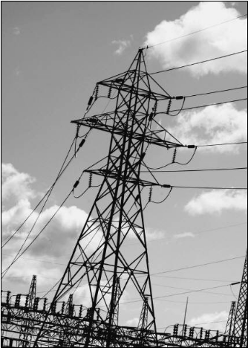

State governments provide many services to state citizens. These include things like police, fire safety, child protective services, roads, schools, and parks. One of the biggest services is maintaining the state’s infrastructure—the basic support structures that serve a geographic area, such as transportation, communication, and power systems. All of these services cost money and are generally paid for with taxes collected from citizens. Usually, however, states cannot afford to provide all the services citizens need. Very often, states look to the federal government for help. The federal government gives states money in the form of grants, which are sums of money designated for a certain purpose such as improving an airport or providing health care to low-income households.
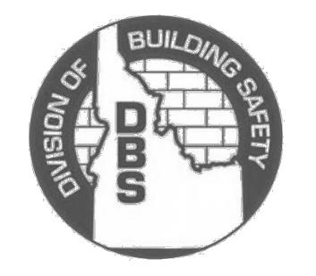

Regulations = Rules

Idaho’s Division of Building Safety issues licenses to electricians, plumbers and others.

State governments also protect citizens by regulating, or making rules about, many activities. Doctors, dentists, accountants, builders, barbers, and many other professionals must be certified by state agencies. State and local governments enforce building codes that specify exactly how buildings must be constructed. They conduct food safety inspections at restaurants, check to make sure gasoline pumps are accurate, and administer tests to people seeking a driver’s license. The state agencies that carry out these regulations are almost always part of the state’s executive branch.

Local Governments

Local governments, such as cities and counties, get their power from the state government. The state decides what services cities and counties are responsible for providing and what kinds of laws cities and counties are allowed to make. Because local governments are the closest to citizens, often they are the ones that can most easily provide services. Some services such as schools, libraries, police, water, and trash collection are usually controlled at the local level. Even so, local governments must follow both state and federal laws when providing these services.

Animal licensing and leash laws are usually controlled by local governments.

Reading p.2

The Great State Name:

A. Vocabulary Search! Find and circle a word that matches each clue. When you find the word, write it on the blank next to the clue.

- Parts of the executive branch that carry out laws.

- A legislature made up of two houses.

- Basic support structures such as communication and power systems.

- Citizens in these geographical areas elect legislators to represent them in the state's legislative branch.

- A state’s judicial branch is made up of these.

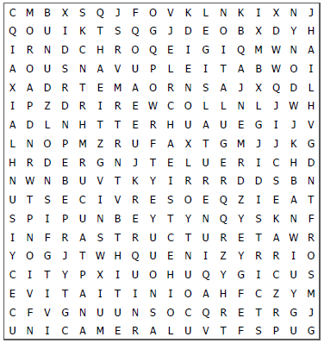
CMBXSQJFOVKLNKIXNJ QOUIKTSQGJDEOBXDYH IRNDCHROQEIGIQMWNA AOUSNAVUPLEITABWOI XADRTEMAORNSAJXQDL IPZDRIREWCOLLNLJWH ADLNHTTERHUAUEGIJV LNOPMZRUFAXTGMJJKG HRDERGNJTELUERICHD NWNBUVTKYIRRRDDSBN UTSECIVRESOEQZIEAT SPIPUNBEYTYNQYSKNF INFRASTRUCTURETAWR YOGJTWHQUENIZYRRIO CITYPXIUOHUQYGICUS EVITAITINIOAHFCZYM CFVGNUUNSOCQRETRGJ UNICAMERALUVTFSPUG

- Each state has one of these to describe how the state government runs. ________________________

- A process that lets citizens place a law on the ballot to be voted on. ________________________

- States provide these to state citizens. ________________________

- A state’s lawmaking body. ________________________

- Money the federal government gives a state for a certain purpose. ________________________

- Another word for rule. ________________________

- A type of local government. ________________________

- The head of a state’s executive branch. ________________________

- Process where citizens vote on a law the state legislature has adopted. ________________________

- A type of local government. ________________________

Mystery Word! What word is in the puzzle but not in the clue list? ______________________________

This word is special because _____________________________________________________________.

Activity p.1

The Great State Name:

B. That’s Incorrect! There’s something wrong with each of the following statements. Figure out what it is. Cross out parts of the sentence and make corrections on the line.

- Unlike the federal government, state governments only have one branch of government.

- States are divided into districts, and citizens in each district elect a governor to be head of their district.

- A state’s executive branch includes many departments that handle thousands of small issues such as misdemeanors.

- States can afford to provide citizens with all necessary services and do not usually need any financial help.

- Local governments are independent and have the power to do anything they want to.

C. Licensed… or Not? When you make an “educated guess,” you are guessing based on things you already know. Read the list of professions below. Which jobs do you think most states require a license for? Think about what these people do and make an educated guess about whether they need a state license. Put a check mark next to every job you think requires a license in most states.

 Architect |  Real Estate Agent |  Event Planner |  Office Manager
 Cashier |  Exterminator |  Teacher |  Massage Therapist
 Dentist |  Private Investigator |  Nail Technician |  Fitness Instructor
 Interpreter |  Car Salesperson |  Embalmer |  Electrician
 Veterinarian |  Software Developer |  Actor |  Hair Dresser

Now choose three jobs you checked. Explain why you think states probably require a license for that.

JOB | PROBABLY REQUIRES A LICENSE BECAUSE...

Reading p.2

